Week  (Commencing) | Communication, Language and Literacy, Maths  (On separate planning) | RE (Mon) | Expressive Arts and Design (Tues) | Understanding the World (Wed) | Personal Social and Emotional Development (Thurs) | Music (Thurs) | Physical Development and Technology (Fri)
1  (1/11) | Firework Description  Representing 1, 2, 3  Comparing 1, 2, 3 | How do people celebrate?  How do we celebrate?  How do people from around the world celebrate?  Class discussion and mind map for display. | Fireworks Painting  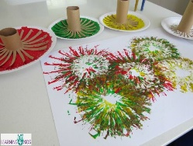 | SWAP UtW AND PSED THIS WEEK  Talk about Bonfire night and using what we are learning in English, why do we celebrate this?  What are you going to do for bonfire night? Talk about fireworks night and safety around bonfires/ fireworks.  On the Creative table for provision, encourage children to make posters about fireworks safety. (Pictures of bonfires and fireworks, writing materials, poster templates, red and yellow tissue paper). | Today is Diwali! Talk through the Diwali PowerPoint. Talk about which religions celebrate it, the Rama and Sita story and how it is known as the festival of light.  On the Creative table, for provision, display resources for children to create their representation of the festival of light.  (Cut out pictures of Rama and Sita, flowers, gold and shiny materials like glitter, sequins and cloth, coloured powder, pictures of candles and lights). | Charanga – My Stories  Step 1  Listen to the song, Alabama. Do you like the song? How does it make you feel?  Game Track – clap along to the beat. Find the pulse  Learn to sing I’m a Little Teapot.  Encourage children to sing a solo in front of the class. | Daily time for bikes, scooters, skipping ropes and footballs.  PE –Warmup game.  Discuss different types of balls and what sports they are used for. Play a simple relay game using different types of balls.  Cool down game.  IT - Children to create a firework picture using Fingerprints or Sketch on the iPads.
Week  (Commencing) | Communication, Language and Literacy, Maths  (On separate planning) | RE (Mon) | Expressive Arts and Design (Tues) | Understanding the World (Wed) | Personal Social and Emotional Development (Thurs) | Music (Thurs) | Physical Development and Technology (Fri)
2  (8/11) | Happy Birthday Maisy  Composition of 1, 2, 3 | Talk about Remembrance Sunday and why people wear poppies.  Cbeebies Poppy Animation  https://www.youtube.com/watch?v=pv_ub7Be7oA  Listen to 'Last Post' Music. How does it make them feel?  Poppy handprint art  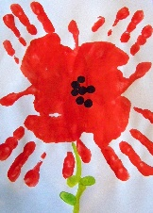 | Provision on the creative table to make birthday cards.  (Card templates, colouring mediums, sequins, glitter, pictures of balloons and cakes for them to cut and stick or copy, envelopes, writing insert templates, old birthday cards for inspiration or to cut up). | Ask children to bring pictures in of their birthdays.  What is a birthday? How do we celebrate birthdays? Talk through the PowerPoint  Children to come to the front to discuss their birthdays. What did you do? Did you have a party? What was your favourite present? Who came to your celebration? | Discuss how when we have parties, who do we invite? We invite our friends. What is a good friend? Discuss what children think initially they think a good friend is.  Complete sorting activity as a class on carpet.  How are they going to be a good friend when they are at school or at home? | Charanga – My Stories  Step 2  Listen to the song, Boogie Wonderland. Do you like the song? How does it make you feel?  Game Track - clap along to the beat. Find the pulse  Recap ‘I’m a Little Teapot’. Discuss what dynamics are. Practice singing the song loudly and quietly.  Encourage children to sing solos at the front of the class. | Daily time for bikes, scooters, skipping ropes and footballs.  PE –Warm up game.  Practice rolling and aiming with balls. Set out an assortment of targets for children to roll their ball into. How many points can the children get?  Cool down game.  IT – E-safety

Week  (Commencing) | Communication, Language and Literacy, Maths  (On separate planning) | RE (Mon) | Expressive Arts and Design (Tues) | Understanding the World (Wed) | Personal Social and Emotional Development (Thurs) | Music (Thurs) | Physical Development and Technology (Fri)
3  (15/11) | Happy Birthday Maisy  Circles and Triangles  Spatial Awareness | The Christmas story – Matthew 1: 18-25, Luke 2: 1-20.  Give children costumes to act out the nativity story.  OR  Using stick puppet nativity characters or the knitted characters retell the story. | Ask parents to bring in party food traditional to their culture’s celebrations for Thursday (optional)  Make and decorate cupcakes for the birthday party on Thursday! | Through a shared write, create an invitation together for Barnaby Bears party (Thursday).  On the creative table, leave provision for children to make their own invitations to invite Barnaby bear to his party.  (Invite templates, colouring and writing mediums, pictures of party items to cut and stick or copy for inspiration and other materials). | Have a birthday party!  Discuss how we behave at a party beforehand. We are kind to our friends, we share the balloons and pass the food politely etc.  - Enjoy party food  - Eat the cupcakes from Tuesday  - Party games – musical statues etc  - Dancing  - Party balloons, hats, plates, and cups  - Hand out presents wrapped from the role play area | Enjoy the music at the birthday party! | Daily time for bikes, scooters, skipping ropes and footballs.  PE –Warmup game.  Work on throwing skills and talk about safety when throwing balls. Play Hit that target. Place two hoops on the floor, close is worth 1 point, and further away is worth 2 points. Discuss about taking a risk or keeping it safe.  Cool down game.  IT - E-safety
Week  (Commencing) | Communication, Language and Literacy, Maths  (On separate planning) | RE (Mon) | Expressive Arts and Design (Tues) | Understanding the World (Wed) | Personal Social and Emotional Development (Thurs) | Music (Thurs) | Physical Development and Technology (Fri)
4  (22/11) | Billy’s Bucket  Four and Five | How did Mary and Joseph prepare for baby Jesus?  Talk about journey to Bethlehem, stable, manger etc.  Not as they would have wanted it to be!  How do we prepare for Christmas/ baby Jesus now? We decorate our houses.  Look at pictures of houses and streets decorated.  Invite children to bring in pictures of their decorations at home over the next couple of weeks to share. | Decorate their own buckets using their designs from English.  (Buckets, designs, and stickers) | Look at different underwater animals using the PowerPoint.  Create an underwater diorama.  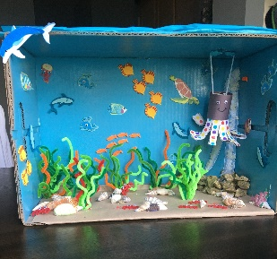  Shoeboxes, pipe cleaners, sand coloured tissue paper, blue paint, string, shells, fish pictures, cardboard tubes, scissors, PVA glue.  (Create letter to ask parents to help with resources) | Hanukkah (On 29/11)  Introduce Hanukkah through the PowerPoint.  What celebration have we learnt about that is similar? (Diwali). They are both the festival of light! They both light candles and eat delicious food! We also do that at Christmas!  Leave provision on the creative table for children to colour Hanukkah pictures and even decorate their own menorah.  Bring in Latkes for children to try. | Charanga – My Stories  Step 3  Listen to the song, Don’t Go Breaking My Heart. Do you like the song? How does it make you feel?  Game Track - clap along to the beat. Find the pulse  Learn ‘The Grand Old Duke of York’. Can you the children add actions while they are singing?  Encourage children to sing solos at the front of the class. | Daily time for bikes, scooters, skipping ropes and footballs.  PE –Warmup game.  Practice using a hockey stick to swipe a ball into a goal. Talk about safety with both the sticks and hitting the ball.  Cool down game.  IT - E-safety
Week  (Commencing) | Communication, Language and Literacy, Maths  (On separate planning) | RE (Mon) | Expressive Arts and Design (Tues) | Understanding the World (Wed) | Personal Social and Emotional Development (Thurs) | Music (Thurs) | Physical Development and Technology (Fri)
5  (29/11) | Billy’s Bucket  One more and one less | Think about other ways we prepare for Christmas.  We count down using advent calendars.  What is advent? How do they help us celebrate?  Look at advent candles – what does each candle represent?  As a class, children make an advent calendar for the class.  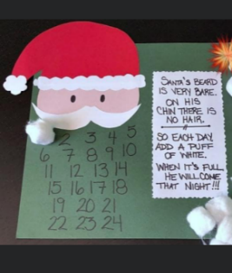 | Fish craft  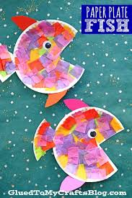  Paper plates, colored tissue paper, googly eyes, coloured card for fins, PVA glue, sequins?  OR  St Andrew’s Day craft | Recap on last lesson.  Create an underwater diorama  Shoeboxes, pipe cleaners, sand coloured tissue paper, blue paint, string, shells, fish pictures, cardboard tubes, scissors, PVA glue. | How can we help at home?  Talk about all the jobs parents do at home. What do they do? How can you help? Why is it important to help? If we don’t help or do as our parents ask, how do you think our parents might feel?  As a shared write, create a thank you card to parents for all they do for the children.  (Take a picture and print for all the parents to take home) | Charanga – My Stories  Step 4  Listen to the song, Ganesh is Fresh. Do you like the song? How does it make you feel?  Game Track - clap along to the beat. Find the pulse.  Learn Ring ‘O’ Roses with actions. | Daily time for bikes, scooters, skipping ropes and footballs.  PE – Warm up game.  Practice balancing a ball in a tennis racket. Can the children pass the ball from one racket to another? Play relay games with balancing a ball on a tennis racket.  Cool down game.  IT - E-safety
Week  (Commencing) | Communication, Language and Literacy, Maths  (On separate planning) | RE (Mon) | Expressive Arts and Design (Tues) | Understanding the World (Wed) | Personal Social and Emotional Development (Thurs) | Music (Thurs) | Physical Development and Technology (Fri)
6  (6/12) | The Snowman  Four sided shapes | Crib scenes – show children a traditional Christmas crib scene (Mary Joseph, Jesus in manger and animals)  Where/ when do we see this scene? Show different photos of crib scenes – shop windows/ ornaments/ images. | Children make crib scenes. (SIAMS project?).  Stable cut out and nativity character stickers.  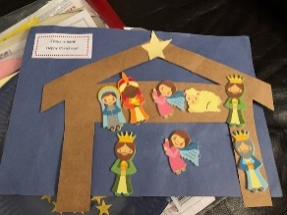 | Talk about weather and seasons. Recap what are the seasons? What weather would you get in the four seasons? What season are we in now?  Talk about snow and experiences of snow. Have you made a snowman? Have you been sledging? Have you had a snowball fight? Have you been on holiday in the snow?  Create a snowman using fake snow. | Keeping safe in the cold/ winter.  It is now getting cold as we are in winter – what do we need to do to keep ourselves safe and healthy? Discuss.  Talk about keeping warm, not spreading germs, putting tissues in the bin, washing our hands. | Charanga – My Stories  Step 5  Listen to the song, Frosty the Snowman. Do you like the song? How does it make you feel?  Game Track - clap along to the beat. Find the pulse.  Learn the song Hickory Dickory Dock. Can the children perform with actions? If the children know the song well, discuss singing in different dynamics.  Encourage children to perform a solo to the class. | Daily time for bikes, scooters, skipping ropes and footballs.  PE – Warm up game.  Children should practice bouncing balls in this lesson. They should learn to bounce the ball themselves and then move onto passing it to a partner.  Cool down game.  IT - E-safety

Week  (Commencing) | Communication, Language and Literacy, Maths  (On separate planning) | RE (Mon) | Expressive Arts and Design (Tues) | Understanding the World (Wed) | Personal Social and Emotional Development (Thurs) | Music (Thurs) | Physical Development and Technology (Fri)
7  (13/12) | The Snowman  Light and Dark | Wise Men – Matthew 2 – How did the wise men celebrate?  They brought gifts to the baby.  Children make a Christmas present for someone special.  Make Christmas shaped shortbreads – put in special Christmas bag with ribbon.  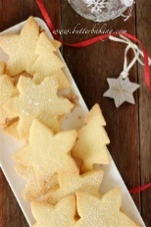  Need…  Butter  Sugar  Flour  Christmas cutters  Baking trays  Greaseproof paper  Christmas bags | Handprint Reindeer art Christmas card  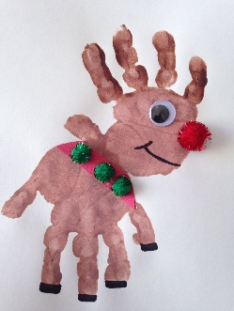  Brown paint, pom poms, black pen, red card strips and googly eye. | Ask children to bring in a picture from Christmas (Decorated house, putting things out for santa, Christmas meal/sack, at church/carol service). Sit in a circle and ask children what they do on Christmas day.  Does your family visit? What do you have to eat? What do you do on Christmas eve? What decorations do you have out? Do you play games? How do you feel on Christmas day?  Do you think everyone has a happy Christmas? Why? Why not?  Talk about families/ children who aren’t as lucky, homeless people – will these people have a big Christmas lunch? Will they get presents?  Discuss charities/ events that help people celebrate Christmas. Discuss foodbank. | Christmas Fun Day  Christmas Party! Food, decorations, music and dancing! | Dancing at the Christmas party! | Daily time for bikes, scooters, skipping ropes and footballs.  PE – Warm up game.  Children will practice passing and catching a ball today. Build up confidence in pairs and then bring children together in a circle. They must pass amongst each other but if someone drops it, the points go back down to zero.  Cool down game.  IT – E-safety

