School name: MATHS PLANNING YEAR A
BRONZE
Teacher: Class: Year: 3-4 Term: Summer 2 Week Commencing: Week 2

Topic |  |  | NC Links:  Pupils should be taught to:  Statistics
Day | Mental/Oral Starter |  |  | Main Lesson |  |  |  | Plenary | Assessment
 | Objectives | Activity |  | Objectives | Teaching | Activities | Key Vocabulary | Activity
Mon | L.O. 7x table  L.O. fluency  406 ÷ 7 =  186 x 7 =  4319+2099 =  800 - 178 = | TMM  L.O. To join the 7x facts |  | L.O. To use line graphs  Must: read the line graph  Should: read the measured data  Could: make estimates for unmeasured data. | Introduce children to line graphs in the context of time.  They use their knowledge of scales to read a time graph and use their own scales to record continuous data.  It is important that children understand that continuous data can be measured but values change all the time. The values we read between actual measurements are only estimates. | Show chn a line graph of temperatures during the day. They answer questions from it.  Give chn a set of data and as a class construct a line graph deciding first on scale.  Jack  launched a toy rocket into the sky.  After 5 seconds the rocket fell to the  ground.  Which graph shows  this?  Explain how you know.  Maths No Problem 4A p147-149 Worksheet 3 | Statistics  Line Graph  x axis  y axis  continuous data | How is a line graph different to bar graphs?  Which is the x/y axis?  What does it show?  How would you estimate temperature at…?  How would you estimate when the temperature was…? | Exceeding ARE:  At ARE:  Below ARE:  SEND  PPG  EAL

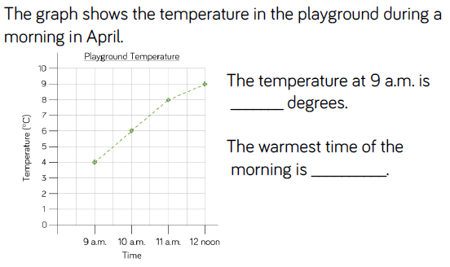
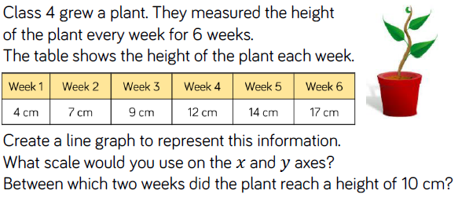
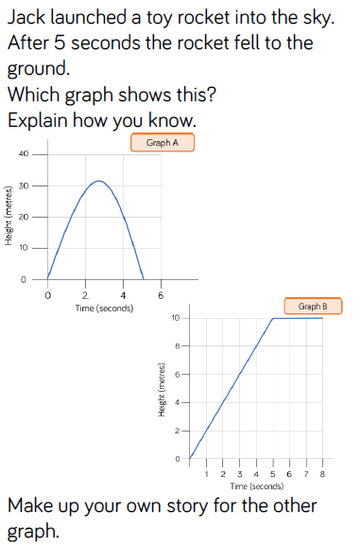

Day | Mental/Oral Starter |  | Main Lesson |  |  |  | Plenary | Assessment
 | Objectives | Activity | Objectives | Teaching | Activities | Key Vocabulary | Activity
Tues | L.O. 7x table  L.O. fluency  558 ÷ 7 =  219 x 7 =  5024+1599 =  650-258 = | TMM  L.O. To work out the values of ?each shape | L.O. To use line graphs  Must: read the line graph  Should: read the measured data  Could: make estimates for unmeasured data. | Building from the last step, teach children to continue to solve comparison, sum and difference problems using continuous data with a range of scales.  Teach them to use addition and subtraction to answer questions  accurately and ask their own questions about the data in line graphs. Although examples of data are given, children need to  have the opportunity to ask and answer questions relating to data they have collected themselves. | Chn answer questions from a line graph.  Chn use reasoning to prove or disprove statements.  Give chn aline graph and they construct a short story that relates to the data.  Maths No Problem 4A p150-158 Worksheets 4 & 5 and Review 5 | Statistics  Line Graph  x axis  y axis  continuous data | Is this discrete or continuous data? How do you know?  What do you notice about the scale of the graph?  How could you make sure you read the graph accurately?  What other questions could you ask about the graph | Exceeding ARE:  At ARE:  Below ARE:  SEND  PPG  EAL

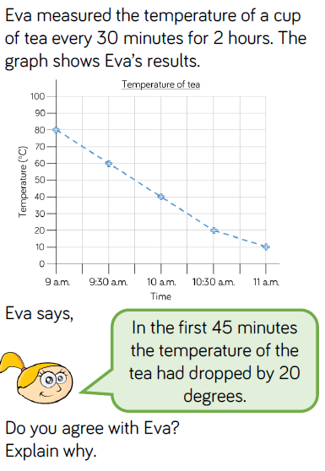
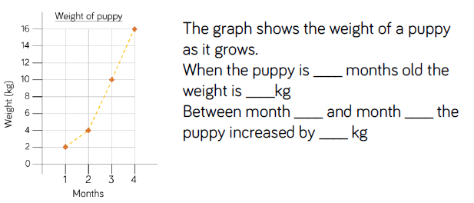
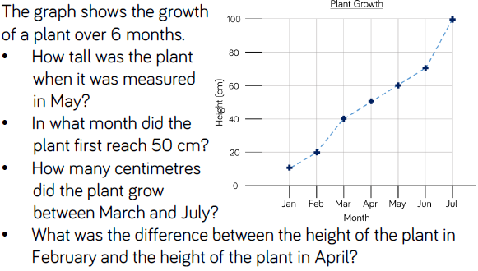

Day | Mental/Oral Starter |  | Main Lesson |  |  |  | Plenary | Assessment
 | Objectives | Activity | Objectives | Teaching | Activities | Key Vocabulary | Activity
Wed |  |  | L.O.  Success Criteria |  | SEN – L.O. |  |  | Exceeding ARE:  At ARE:  Below ARE:  SEND  PPG  EAL

Day | Mental/Oral Starter |  | Main Lesson |  |  |  | Plenary | Assessment
 | Objectives | Activity | Objectives | Teaching | Activities | Key Vocabulary | Activity
Thurs |  |  | L.O.  Success Criteria |  | SEN – L.O. |  |  | Exceeding ARE:  At ARE:  Below ARE:  SEND  PPG  EAL

Day | Mental/Oral Starter |  | Main Lesson |  |  |  | Plenary | Assessment
 | Objectives | Activity | Objectives | Teaching | Activities | Key Vocabulary | Activity
Fri |  |  | L.O.  Success Criteria |  | SEN – L.O. |  |  | Exceeding ARE:  At ARE:  Below ARE:  SEND  PPG  EAL

