School name: MATHS PLANNING YEAR A
BRONZE
Teacher: Class: Year: 3-4 Term: Autumn 1 Week Commencing: Week 4

Topic |  |  | NC Links:  Pupils should be taught to:  Place Value
Day | Mental/Oral Starter |  |  | Main Lesson |  |  |  | Plenary | Assessment
 | Objectives | Activity |  | Objectives | Teaching | Activities | Key Vocabulary | Activity
Mon | L.O. Recall 3x table  L.O. fluency  Y3  183+52=  144-21=  17x3=  24÷3=  Y4  4315+589 =  700 – 202 =  189 x 3 =  369 ÷ 3 = | TMM  L.O. To tick or X and explain why some calculations are wrong |  | L.O.  To round to the nearest 10.  Success Criteria:  Must: Round 2-digit numbers to nearest 10  Should: Round 3-digit numbers to nearest 10  Could: Round any number to the nearest 10 | Teach chn to look at a 2-digit number on a number line and decide which multiple of 10 it is closer to. They then apply their understanding to 3-digit numbers focussing on the 1s and rounding up and down.  Teach chn the importance of 5 and even though it is in the middle of 0 and 10, 5 always rounds up.  What is a multiple of 10?  Which multiples of 10 does … sit between?  Which column do we look at if we are rounding to the nearest 10?  What do we do if the number in that column is 5? | Which multiples of 10 does … sit between?  Which multiple of 10 is the number closer to?  Chn round numbers to nearest 10.  Given a rounded number, what could the original number have been? List all possibilities | Rounding  Multiples  Nearest  Ones  Tens | Which column do we look at if we are rounding to the nearest 10?  What do we do if the number in that column is 5? | Exceeding ARE:  At ARE:  Below ARE:  SEND  PPG  EAL

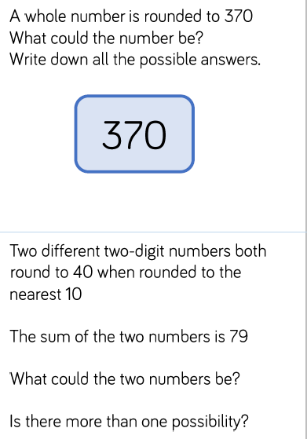
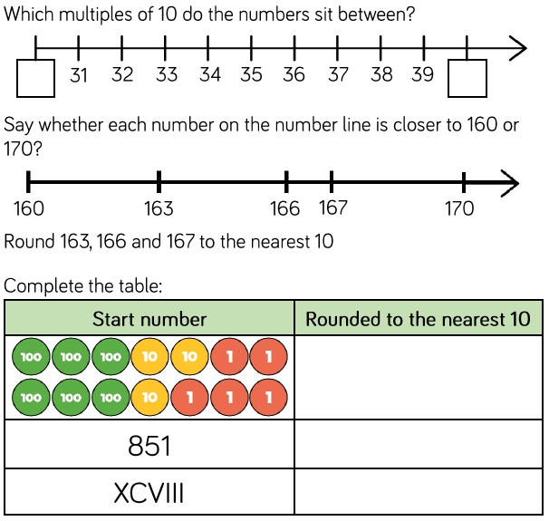
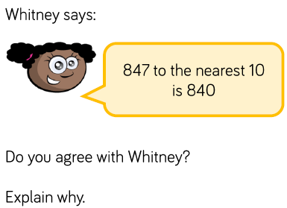

Day | Mental/Oral Starter |  | Main Lesson |  |  |  | Plenary | Assessment
 | Objectives | Activity | Objectives | Teaching | Activities | Key Vocabulary | Activity
Tues | L.O. Times Table Test  L.O. fluency  Y3  171-51=  125+124=  15x6=  60÷6=  Y4  3851 +3585 =  702-418 =  189 x 6 =  372 ÷ 6 = | TMM  L.O. <, > or = | L.O.  To round to the nearest 100.  Success Criteria:  Must: Round 3-digit numbers to nearest 100  Should: Round 4-digit numbers to nearest 100  Could: Round any number to the nearest 100 | Teach chn to compare rounding to 10 where they look at the 1s column to rounding to 100 where they look at the 10s column.  Chn use knowledge of multiples of 100 to understand which two multiples of 100 a number sits between.  What is the same/different about rounding to the nearest 10 or 100? | Which multiples of 100 does … sit between?  Which multiple of 100 is the number closer to?  Chn round numbers to nearest 100.  Given a rounded number, what could the original number have been? List all possibilities  Always sometimes never statements. | Rounding  Multiples  Nearest  Ones  Tens  Hundreds | Why does 49 round down and 50 round up?  Can the answer be 0 when rounding? | Exceeding ARE:  At ARE:  Below ARE:  SEND  PPG  EAL

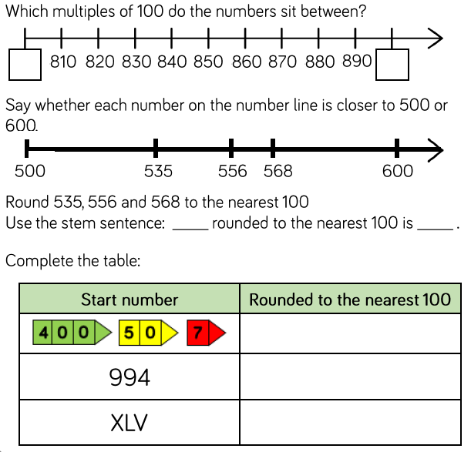
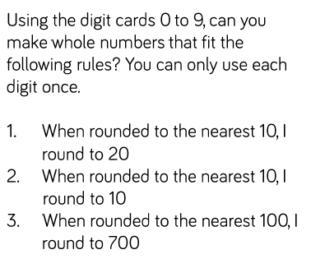
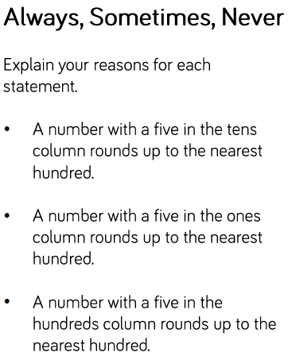
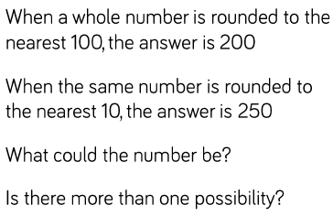

Day | Mental/Oral Starter |  | Main Lesson |  |  |  | Plenary | Assessment
 | Objectives | Activity | Objectives | Teaching | Activities | Key Vocabulary | Activity
Wed | L.O. Recall 6x table  L.O. fluency  Y3  12 x 6 =  36 ÷ 6 =  195 – 74 =  182 + 106 =  Y4  336 ÷ 6 =  478 x 6 =  400- 98 =  6291 + 1829 = | TMM  L.O. Grid of multiples of 6x tables | L.O.  To round to the nearest 1000.  Success Criteria:  Must: Round 3-digit numbers to nearest 1000  Should: Round 4-digit numbers to nearest 1000  Could: Round any number to the nearest 1000 | Teach chn to build on knowledge of rounding to nearest 10 and 100 to round to nearest 1000.  Chn must understand which multiple of 1000 a number sits between.  When rounding to 1000, children should look at the 100s column | Target Your Maths 4 p10 Challenges A, B & C  Maths – No Problem 4A Worksheets 11-14 p 14-19 | Rounding  Multiples  Nearest  Ones  Tens  Hundreds  Thousands | A number is rounded to the nearest 1000. The answer is 7000.  What is the greatest number the original number could have been? What is the smallest it could have been? | Exceeding ARE:  At ARE:  Below ARE:  SEND  PPG  EAL

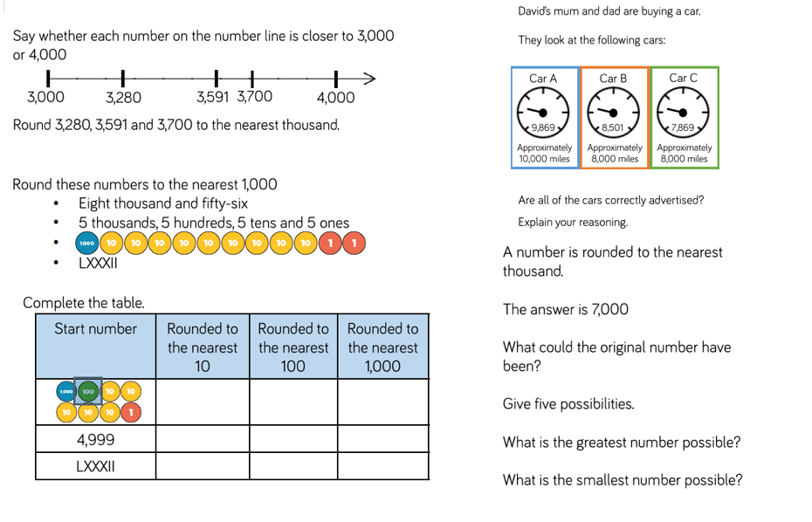

Day | Mental/Oral Starter |  | Main Lesson |  |  |  | Plenary | Assessment
 | Objectives | Activity | Objectives | Teaching | Activities | Key Vocabulary | Activity
Thurs | L.O. Recall 6x table  L.O. fluency  Y3  42 ÷ 6 =  16 x 6=  140 - 20 =  122 + 27 =  Y4  783÷6=  299x6=  4198+2745=  500-372 = | TMM  L.O.To fill in a web | L.O. To compare objects  Must: Know numbers to 1000  Should: Use comparative language to compare. | Teach chn to use objects to represent numbers to 1000. They use comparative language and symbols to determine which is greatest/smallest.  Chn use concrete manipulatives or draw them pictorially.  Use stem sentences to ensure correct vocabulary. | Chn represent numbers with place value counters and Base 10.  Exercises to use <, > or =  Odd one out exercise  Maths No Problem 3A Worksheet 4 p9-13 | Greater  Smaller  Equal | How do you know which number is greater?  Do you count 100s, 10s or 1s first? | Exceeding ARE:  At ARE:  Below ARE:  SEND  PPG  EAL

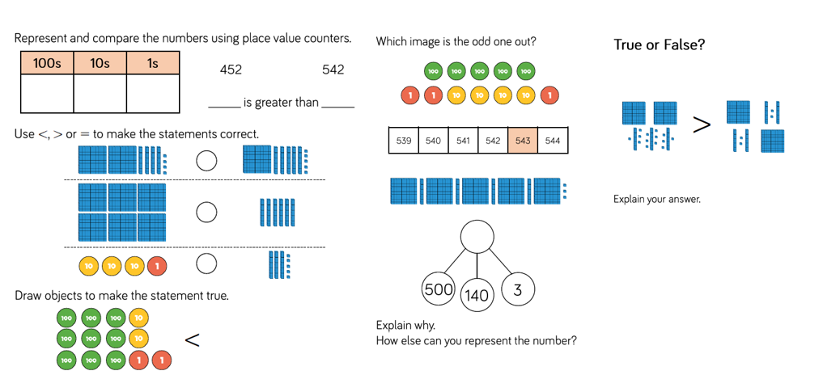

Day | Mental/Oral Starter |  | Main Lesson |  |  |  | Plenary | Assessment
 | Objectives | Activity | Objectives | Teaching | Activities | Key Vocabulary | Activity
Fri | L.O. Recall 6x table  L.O. fluency  Y3  54÷6=  40x6=  169-34=  134+12=  Y4  6084+747 =  450 - 148 =  405 x 6 =  316 ÷ 6 = | TMM  L.O. Fill in a Venn Diagram | L.O. To Compare \numbers  Must: Know numbers to 1000  Should: Use comparative language to compare | Teach chn to compare numbers using inequality symbols.  Chn need to choose an efficient method to compare the numbers. | Maths No Problem 4A Worksheets 6 & 7 p8-10 | Greater  Smaller  Equal | What strategy did you use to compare the numbers?  Can you find more than one way to complete the statements? | Exceeding ARE:  At ARE:  Below ARE:  SEND  PPG  EAL

