School name: MATHS PLANNING YEAR A
BRONZE
Teacher: Class: Year: 3-4 Term: Summer 1 Week Commencing: Week 6

Topic |  |  | NC Links:  Pupils should be taught to:  Time
Day | Mental/Oral Starter |  |  | Main Lesson |  |  |  | Plenary | Assessment
 | Objectives | Activity |  | Objectives | Teaching | Activities | Key Vocabulary | Activity
Mon | L.O. 12x table  L.O. fluency  2088+699=  705-488=  18x12=  777÷12= | TMM  L.O. Greater than, less than or = |  | L.O. To find the duration  Must: read the time  Should: find the duration of events  Could: solve problems | Teach children to find the durations of events using both analogue and  digital clocks. They should be given opportunities to practically work out durations of time using clocks with moveable hands.  Number lines are also a useful model.  Children explore the most efficient ways of breaking the time down in order to work out the duration. For example: half hours, quarter of an hour and five minutes. | Chn calculate the duration of tv programmes.  They calculate journey times.  Maths No Problem 3B p51  Worksheet 16  Maths No Problem 4A p190/191 Worksheet 4 | To  Past  Minutes  O’clock  Hours  Am  Pm  Morning afternoon  Evening  Earlier  Later  Duration | When did the event start? When did it finish? What was the duration?  How many minutes is a full turn of the clock?  Do we need to count each individual minute?  Can we break down the time differently to make it easier to count? | Exceeding ARE:  At ARE:  Below ARE:  SEND  PPG  EAL

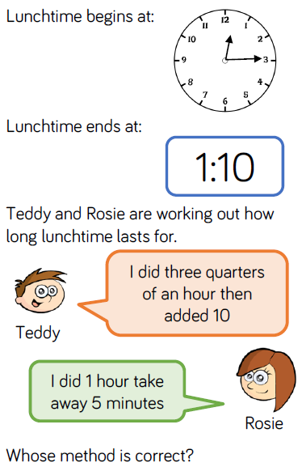
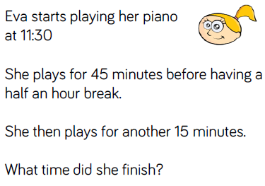
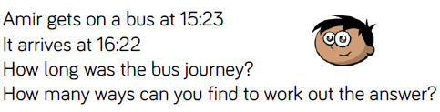
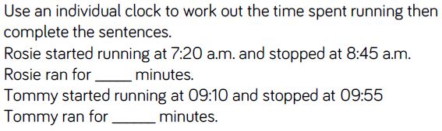
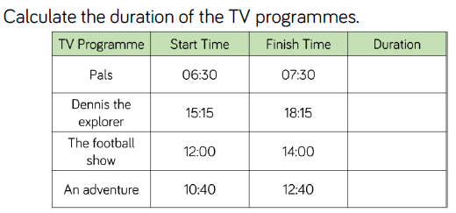

Day | Mental/Oral Starter |  | Main Lesson |  |  |  | Plenary | Assessment
 | Objectives | Activity | Objectives | Teaching | Activities | Key Vocabulary | Activity
Tues | L.O. 12x table  L.O. fluency  15 x 12 =  271 ÷ 12 =  810 - 377 =  456 + 1478 =  180cm = ?m | TMM  L.O. To fill in a Venn diagram | L.O. To compare duration  Must: read the time  Should: compare the duration of events  Could: solve problems | Teach children to compare durations of time using analogue and digital clocks. They could use empty number lines to model the situations as these will assist with bridging over hours.  They use their knowledge of addition and subtraction, and that there are 60 minutes in an hour, to compare the length of time  taken by particular events or tasks. | Use the class timetable to compare duration of lessons  They use inequality symbols to make statements correct.  Chn look at timetables and compare train journey duration.  Target Your Maths 3 p95 Challenges A, B & C.  Target Your Maths 3 p96 Challenges A, B & C. | Minutes  Hours  Start  Finish  Length  Add  Subtract  Duration | Which is the longest amount of time?  Which is the shortest amount of time?  Is _______ longer or shorter than _____?  How much longer was ______?  How much shorter was ______? | Exceeding ARE:  At ARE:  Below ARE:  SEND  PPG  EAL

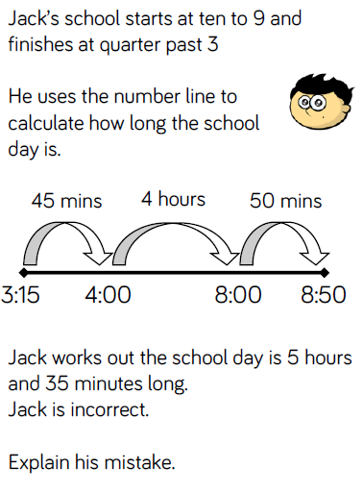
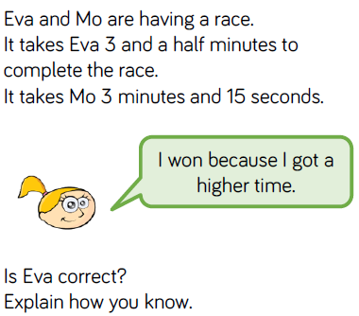
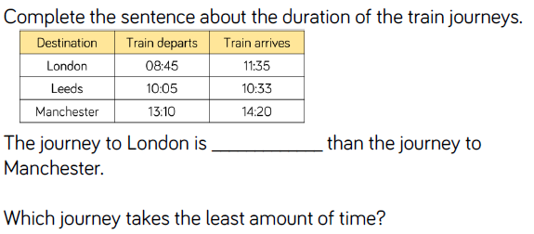
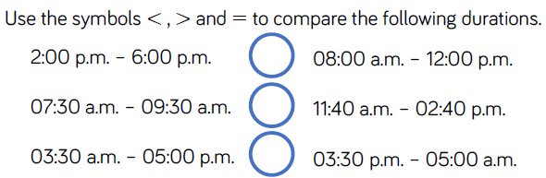
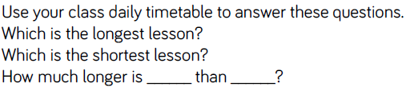

Day | Mental/Oral Starter |  | Main Lesson |  |  |  | Plenary | Assessment
 | Objectives | Activity | Objectives | Teaching | Activities | Key Vocabulary | Activity
Wed | L.O. 12x table  L.O. fluency  4545+2299=  400-198=  19x12=  194÷12= | TMM  L.O. To fill in the missing numbers | L.O. To find start and end times as well as duration  Must: find start and end times.  Should: find the duration of events  Could: solve problems | Teach children to find start and end times to the nearest minute using both analogue and digital times.  They could use real clocks with moveable hands whilst learning how to add and subtract times, and then move to number lines to help calculate start and end times.  Part whole models could also be used to split longer intervals.  What time should the number line start at?  Will you jump forwards or backwards?  How many intervals will you break the duration into? Would a part whole model help? | Chn calculate end times of programmes of known start time and duration.  Target Your Maths 4 p108 Challenges A, B & C.  Target Your Maths 4 p109 Challenges A, B & C. | Minutes  Hours  Start  Finish  Length  Add  Subtract  Duration | They identify errors and misconceptions and rectify explaining reasoning. | Exceeding ARE:  At ARE:  Below ARE:  SEND  PPG  EAL

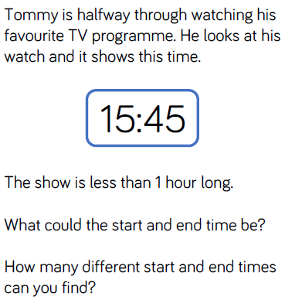
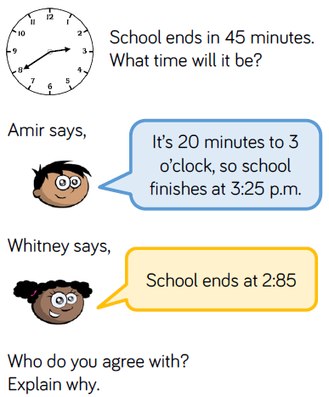
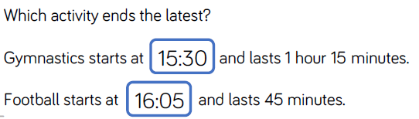
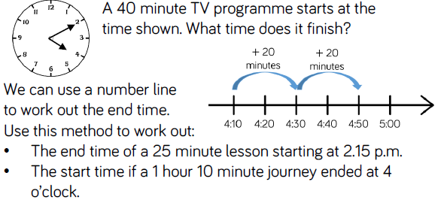
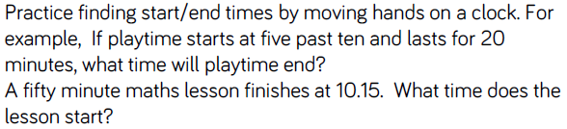

Day | Mental/Oral Starter |  | Main Lesson |  |  |  | Plenary | Assessment
 | Objectives | Activity | Objectives | Teaching | Activities | Key Vocabulary | Activity
Thurs | L.O.  12x table  L.O. fluency  7099+2981=  900-492=  100x12=  444÷12= | TMM  L.O. To Fill in a Web | L.O. To measure in seconds and convert between units of time  Must: measure time in seconds  Should: convert units of time  Could: solve problems | Teach children to measure and compare durations of time in seconds.  It is important for children to have a realistic sense of what time in seconds feels like, as they often count in seconds too quickly. They could use a stopwatch to compare, for example,  counting to 10 seconds in their heads with the actual timed duration. They recognise that there are 60 seconds in one minute and use this to write durations of time in different ways  e.g . 80 seconds is the same as 1 minute and 20 seconds.  How many seconds are there in 1 minute? | Children use a stopwatch to find the length of time it takes, in  seconds, to complete different tasks. For example, run across the  hall/playground, do 10 star jumps, write their name. How long did each task take?  Order the tasks based on the time they took to complete. Convert units of time  Maths No Problem3B p44 Worksheets 10 & 11  Maths No Problem 4A p187 Worksheet 2 | Seconds  Minutes  Hours  Start  Finish  Length  Add  Subtract  Multiply divide  Duration | Can you suggest a task that lasts _____ seconds?  If a task takes longer than 60 seconds, how else could we  record the duration of time?  How could we work out how many seconds there are in _____  minutes? | Exceeding ARE:  At ARE:  Below ARE:  SEND  PPG  EAL

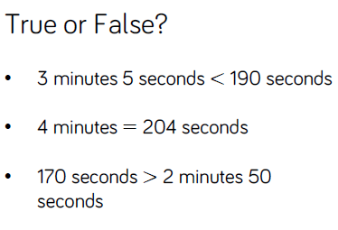
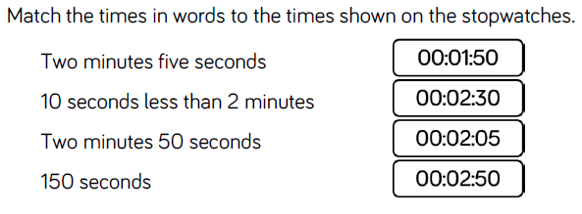
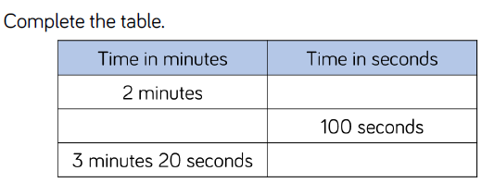
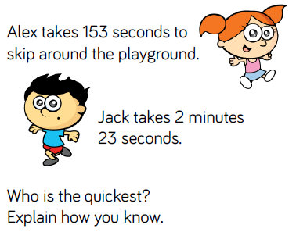
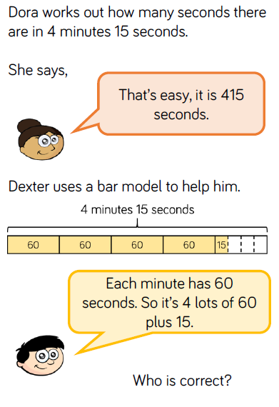

Day | Mental/Oral Starter |  | Main Lesson |  |  |  | Plenary | Assessment
 | Objectives | Activity | Objectives | Teaching | Activities | Key Vocabulary | Activity
Fri |  |  | L.O.  Success Criteria |  | SEN – L.O. |  |  | Exceeding ARE:  At ARE:  Below ARE:  SEND  PPG  EAL

