Continuous Provision
Week Beginning: 12/04/21

Sand | Mud Kitchen | Role play | Maths | English | Mark Making | Creative | Construction | Small World | Motor Skills
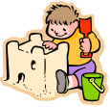 | 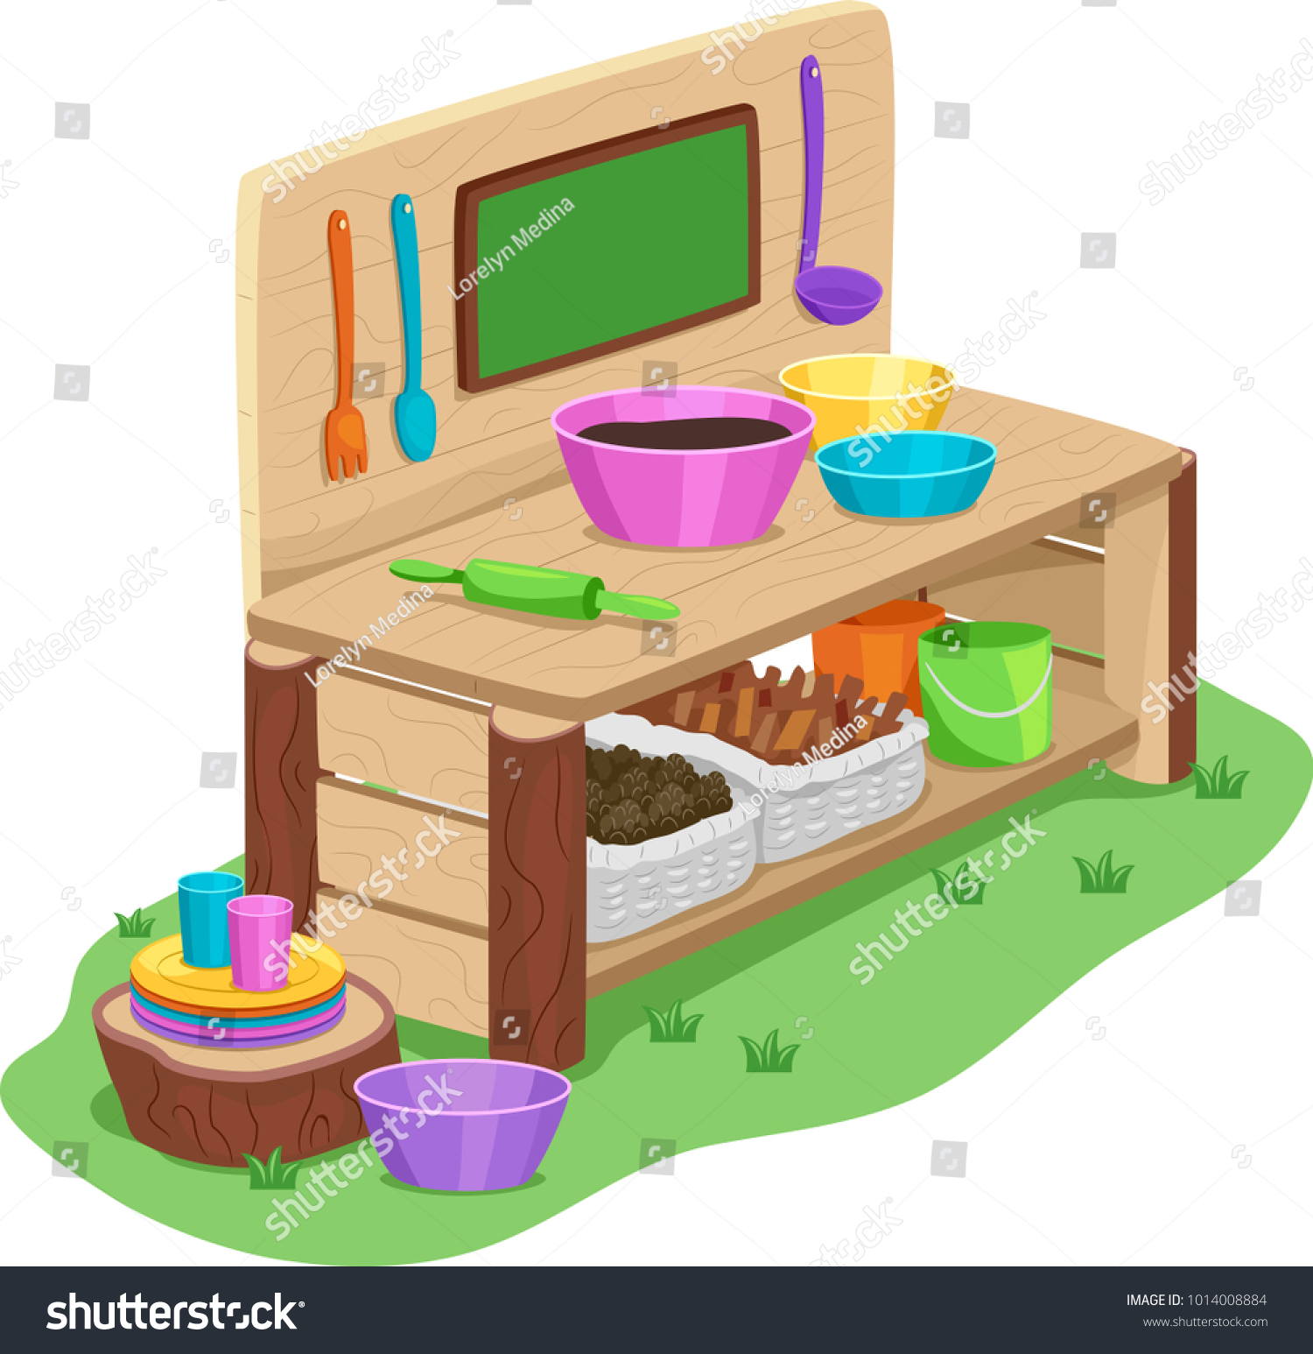 |  |  |  |  |  | 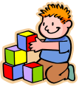 |  | 
Can you make worm tunnels in the sand? | Coloured spaghetti with worms – how many worms can you find? | Mini beast investigation area - mini beast checklist, magnify glasses, bugs etc. | Provide black outlines of a cityscape for the  children to fill using the number shapes. Can  they see which number has filled each tower?  Is there more than one way to do this? Can  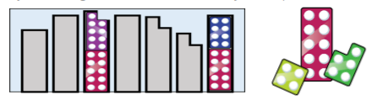  they design their own cityscape? | Create a reading tent with worm/ minibeast books for children to share.  Books could include… Superworm, Worms (Dirty Bertie), Diary of a Worm, Don't Poke a Worm Till it Wriggles, Eddie’s Garden: and How to Make Things Grow, Grandpa's Garden, Wonderful Worms. | Create worm tracks with string or wool dipped in paint and trailed or wriggled along paper.  Draw worms on the blackboards outside. | Creative station including; mini beast stickers, shape stickers, flower stickers, sequins, wool, cut up paper, pom poms, googly eyes, paper, scissors, tape, coloured pencils, crayons, felt tips, stencils,  Etc.  Painting using mini beast shaped sponge stamps. | Build towers of stacking counters.  Children should roll the dice and add the two numbers together. Children should build a tower with that number of counters. | Mud/ leaves/ flowers with plastic minibeasts, minibeast identification sheets and investigation tools – magnifying glasses, tweezers.  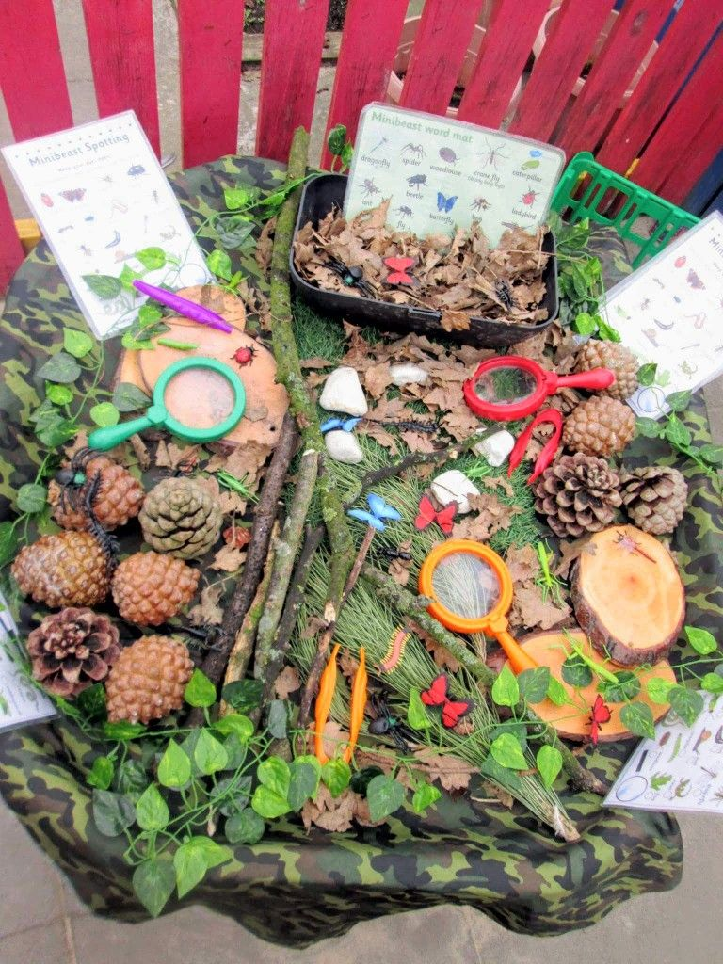 | Make worms using playdough.

