Continuous Provision
Week Beginning: 18/1/20

Mud Kitchen | Water | Role play | Maths | English | Mark Making | Creative | Construction | Small World | Motor Skills
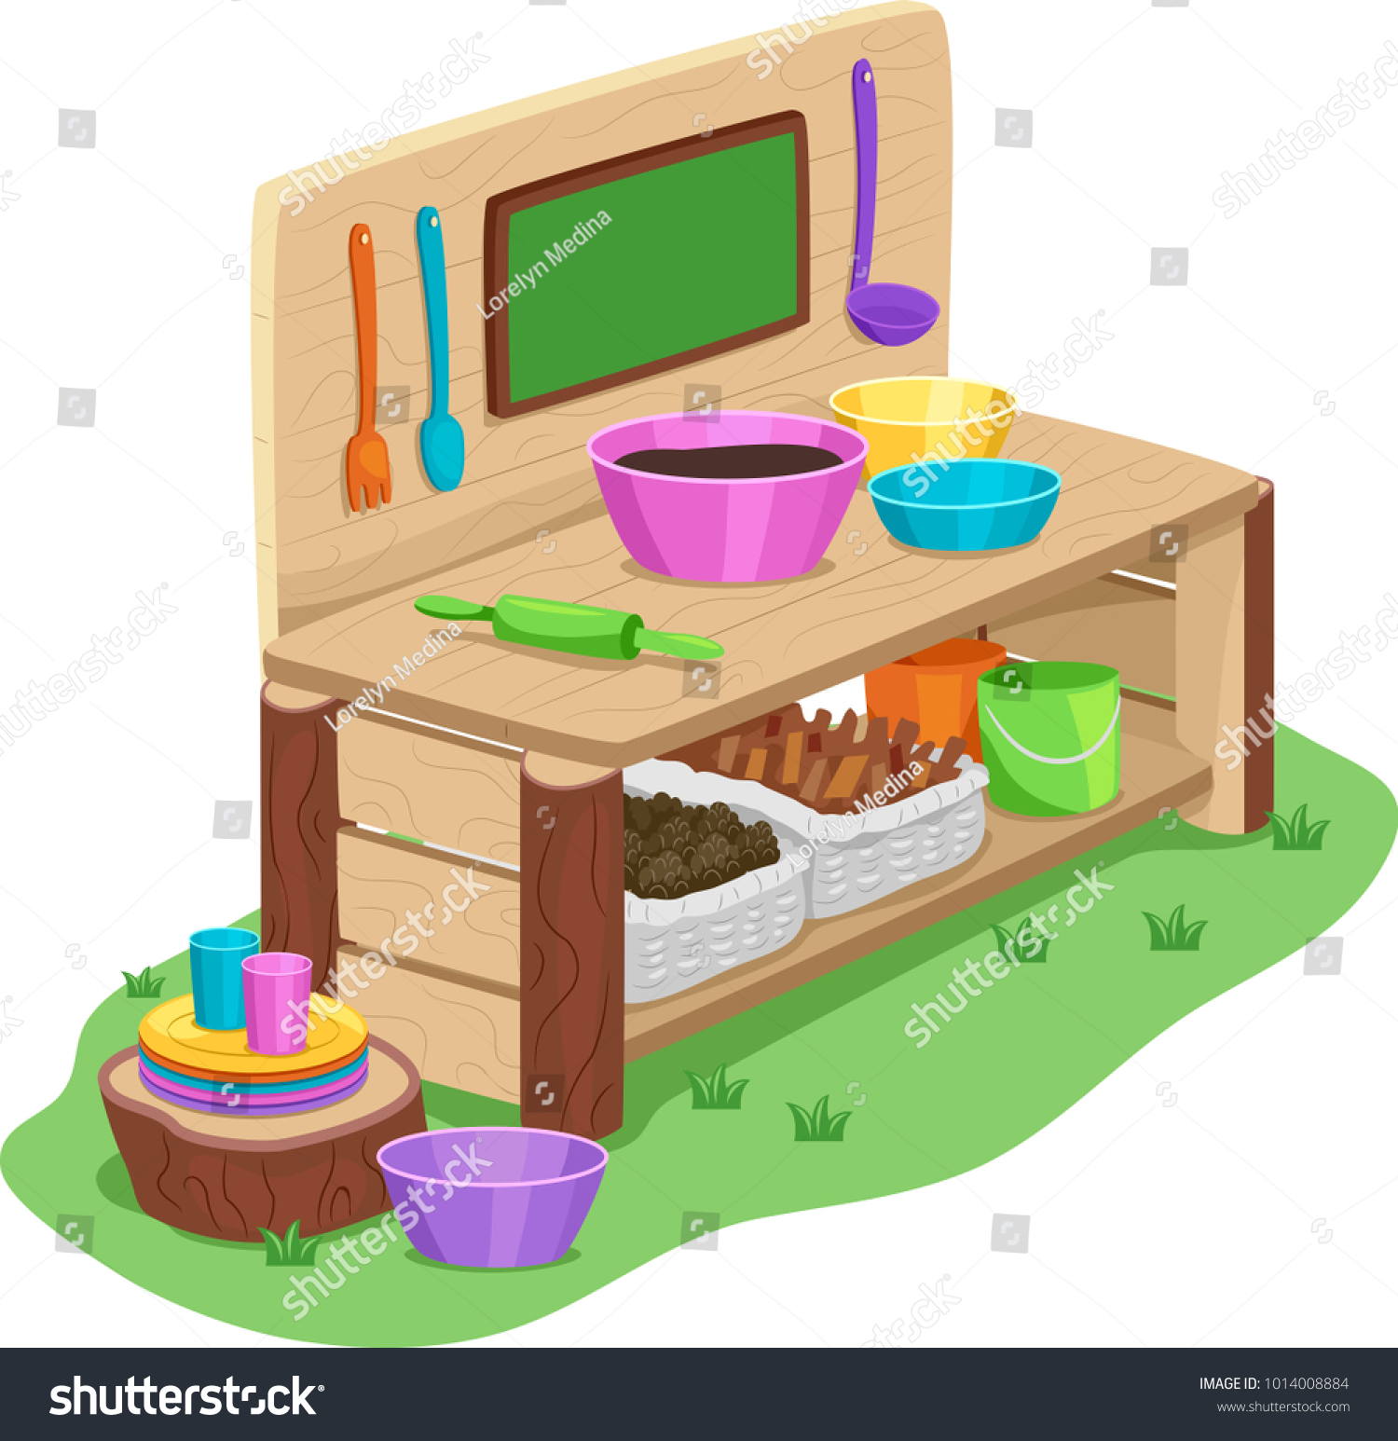 | 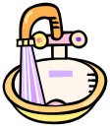 |  | 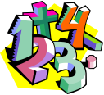 |  |  |  | 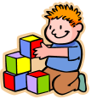 | 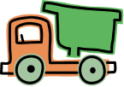 | 
Children measure out ingredients using a variety of pans, bowls, spoons  and ladles. Children could follow a recipe to measure out the ingredients. | Provide a  variety of jugs and beakers. Encourage the ‘waiters’ to take drinks orders and bring out the drinks to customers. Try to model the language of nearly full, half full, nearly empty etc and enjoy your  delicious drinks! | Castles | Provide a set of balance scales and an  assortment of loose parts to compare.  Encourage the children to use the  mathematical vocabulary of heavier than  and lighter than as they compare the  different items. | Read fairy tales in the tent. | Three Little Pigs pencil control sheets | Mon – Tues: Three Little Pig cone characters  Wed- Thurs: Three Little Pigs colouring sheets | Build a house out of straw and sticks. | Three Little Pigs tuff tray  Pigs, wolf, straw, sticks, bricks (lego), pictures of houses etc.  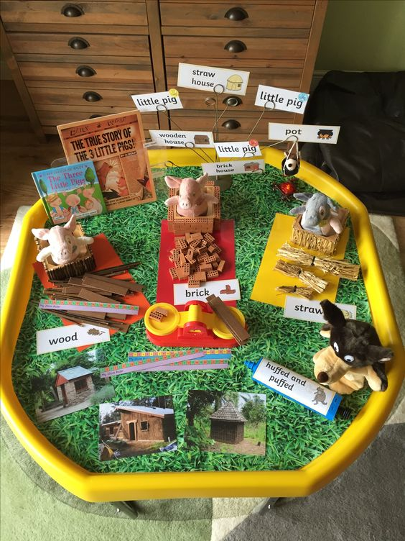 | Three Little Pigs playdough mats

