Continuous Provision
Week Beginning: 25/1/20

Mud Kitchen | Water | Role play | Maths | English | Mark Making | Creative | Construction | Small World | Motor Skills
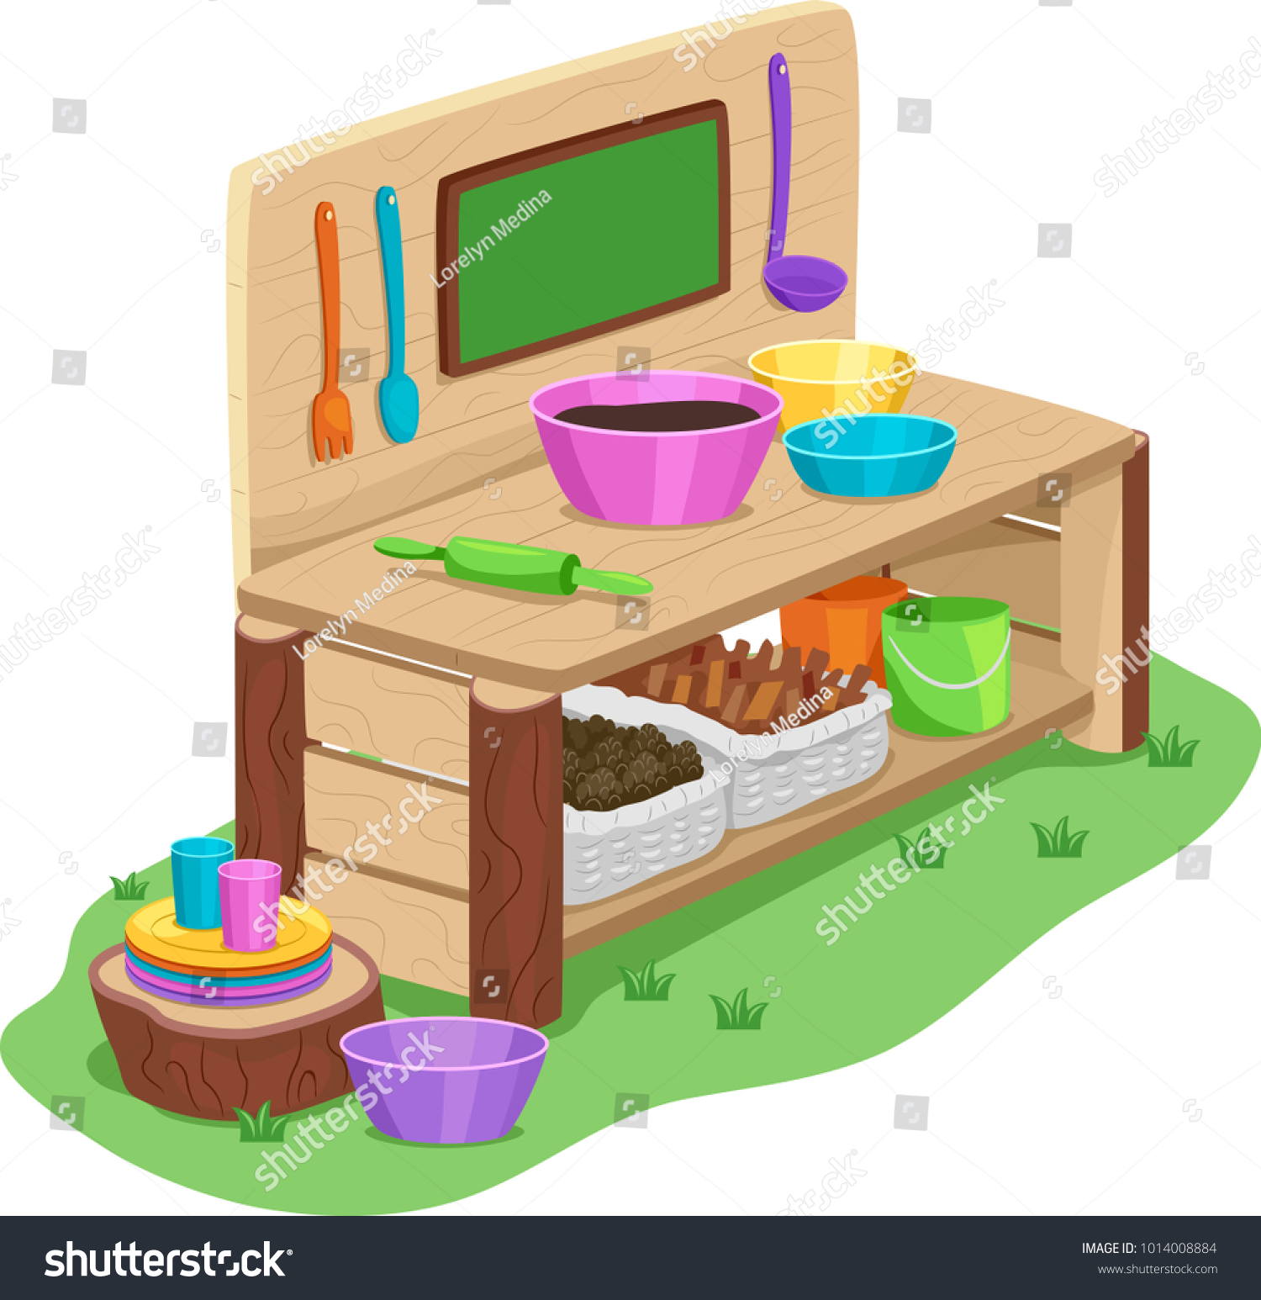 | 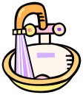 |  | 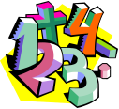 |  |  |  | 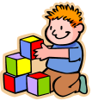 | 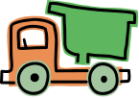 | 
Fill mud kitchen with mud and fake insects. Using magnifying glasses, children have to find the bugs and count their legs. How many legs? Can they record their findings? | Animals and a Noah’s ark in the water tray. Can the children put the animals on the ark in pairs? | Castle | Mon – Tues: Have different representations of 6, 7, 8 on the table for children to sort  Wed – Thurs: Noah Ark pairs game? | Three Little Pigs Sentence building cards | On the chalkboards, can you draw the different houses from the Three Little Pigs?  Straw, sticks, bricks. | Mon – Tues: Split pin characters  Wed- Thurs: Children make their own three little pig role play masks | Build a house of bricks (lego) | Three Little Pigs tuff tray.  Pigs, wolf, straw, sticks, bricks (lego), pictures of houses etc.  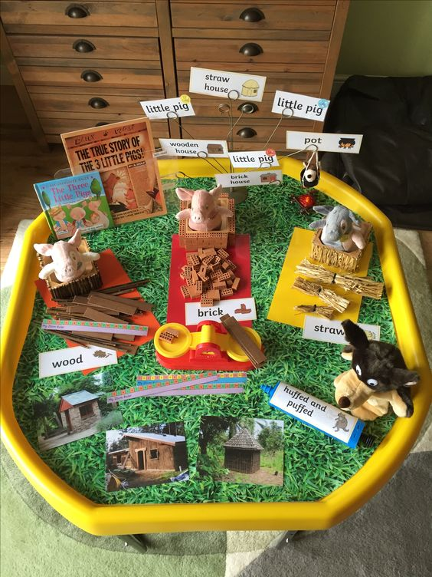 | Three Little Pigs cutting skills

