School name: MATHS PLANNING YEAR A
BRONZE
Teacher: Class: Year: Term: Autumn 1 Week Commencing: Week 1

Topic |  |  | NC Links:  Pupils should be taught to:
Day | Mental/Oral Starter |  |  | Main Lesson |  |  |  | Plenary | Assessment
 | Objectives | Activity |  | Objectives | Teaching | Activities | Key Vocabulary | Activity
Mon | L.O. Recall 9x table  L.O. fluency  159x9 =  431÷9=  4478+3129=  900-446= | TMM  L.O. To fill in a web |  | L.O.  To add and subtract lengths  Must: convert units  Should: add and subtract lengths  Could: solve problems  Success Criteria | Teach children to add and subtract lengths given in different units of measurement. They convert measurements to the same unit of length to add more efficiently. Children should be encouraged to look for the most efficient way to calculate and develop their mental addition strategies.  This step helps prepare children for adding lengths when they calculate the perimeter and for finding missing lengths within perimeter. | Exercises that allow chn to add and subtract lengths given in different units of measurement. They convert measurements to the same unit of length.  SEN – L.O. | Metres  Centimetres  Millimetres  Add  Subtract  Difference | Why does converting the measurements to the same unit of length make it easier to add and subtract them? | Exceeding ARE:  At ARE:  Below ARE:  SEND  PPG  EAL

Why does converting the measurements to the same unit of length make it easier to add and subtract them?
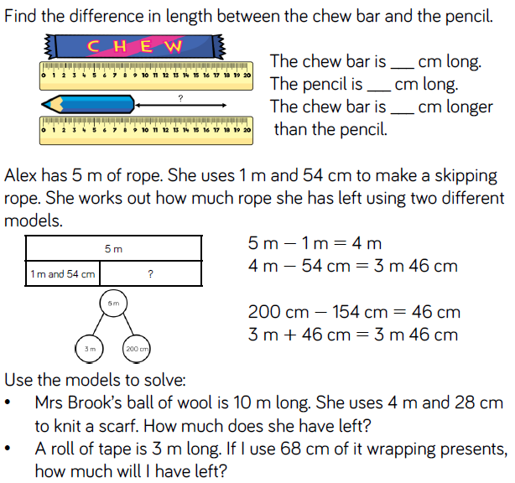
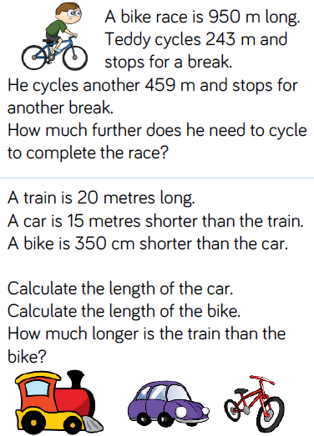

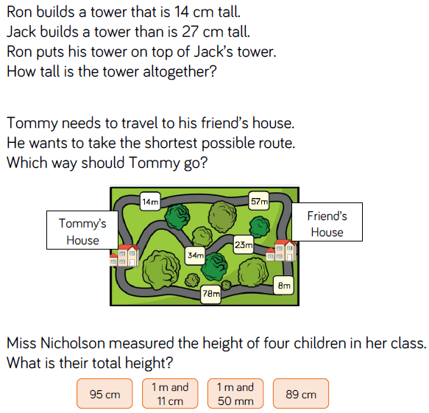

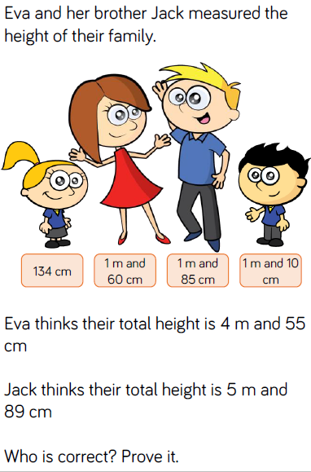
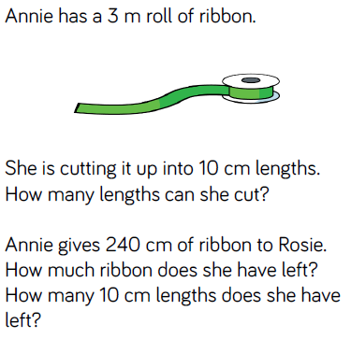
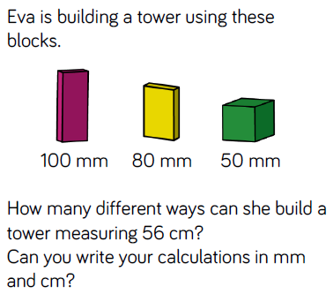

Day | Mental/Oral Starter |  | Main Lesson |  |  |  | Plenary | Assessment
 | Objectives | Activity | Objectives | Teaching | Activities | Key Vocabulary | Activity
Tues | L.O. Recall 9x table  L.O. fluency  206x9 =  716÷9=  4101+4999=  800-266= | TMM  L.O. To complete the Venn Diagram | L.O. To measure perimeter.  Must: Find all sides of a shape for perimeter  Should: realise that you don’t need to measure all sides of regular shapes  Could: experiment with shapes of the same area to find different perimeters.  Success Criteria | Teach chn to explore perimeter: what is it? What is it not?  Children measure the perimeter of simple 2d shapes. They compare different 2d shapes that have the same perimeter.  Chn recognise that you need all sides to measure perimeter but you may not have to measure all sides. | Chn investigate perimeter by tracing around the outside of objects with their fingers.  Show a variety of shapes. Chn decide if they need to measure all sides.  Chn experiment by drawing different shapes of 8, 1cm squares and measuring the perimeter. How many different perimeters can you find?  SEN – L.O. | Measure  Perimeter  Outside  Add  multiply | Do you need to measure all sides of a rectangle to find the perimeter? How many measurements do you need to make to measure the perimeter of a square? | Exceeding ARE:  At ARE:  Below ARE:  SEND  PPG  EAL

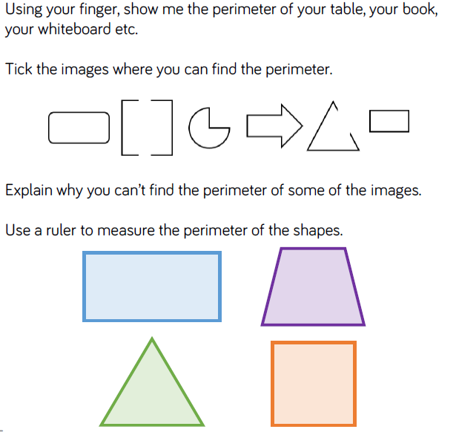
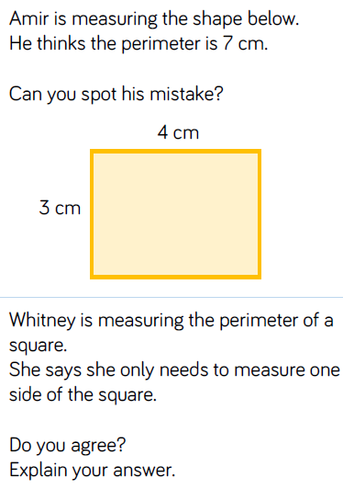
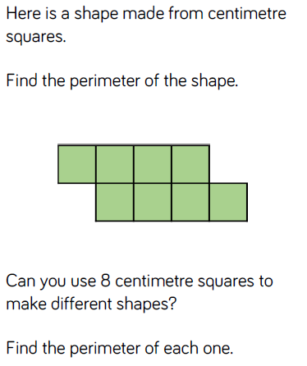

Day | Mental/Oral Starter |  | Main Lesson |  |  |  | Plenary | Assessment
 | Objectives | Activity | Objectives | Teaching | Activities | Key Vocabulary | Activity
Wed | L.O. Recall 9x table  L.O. fluency  369x9 =  881÷9=  5189+777=  911-456= | TMM  L.O. Greater than, less than or equal to | L.O. To Calculate Perimeter  Must: Calculate the perimeter by adding the length of sides  Should: use multiplication to find perimeter when applicable  Could: find missing lengths when given the perimeter.  Success Criteria | Teach children to use their understanding of the properties of shape to calculate the perimeter of simple 2-D shapes.  It is important to note they will not explore the formula to find the perimeter of a rectangle at this point.  They explore different methods for calculating the perimeter of a shape. For example, they may use repeated addition or they may make connections to multiplication. | Chn use their knowledge of properties of shape to find the perimeter of simple 2d shapes using repeated addition and multiplication.  They find missing lengths when given the perimeter.  Chn create different rectangles with a perimeter of 20cm.  SEN – L.O. | Measure  Perimeter  Outside  Add  multiply | How can we calculate the perimeter of each shape?  Can we calculate the perimeter using a different method?  How can we work out the length of the missing side? | Exceeding ARE:  At ARE:  Below ARE:  SEND  PPG  EAL

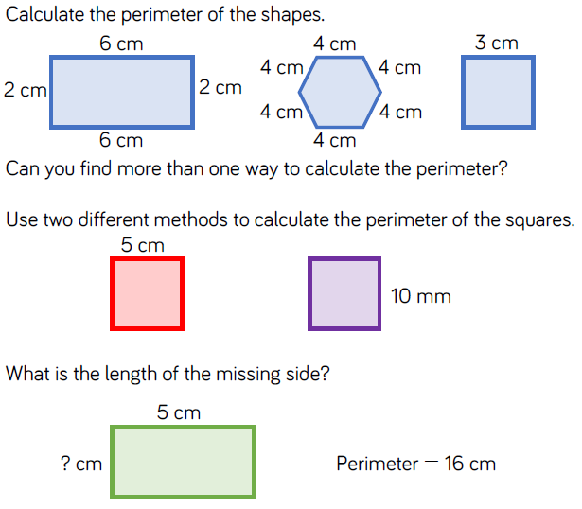
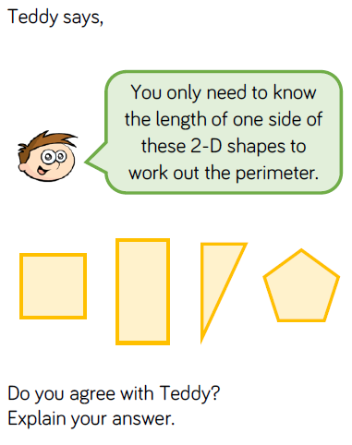
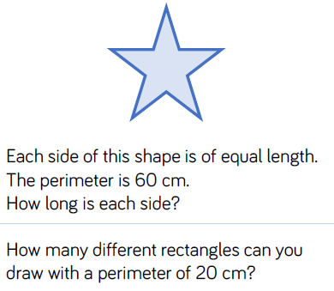

Day | Mental/Oral Starter |  | Main Lesson |  |  |  | Plenary | Assessment
 | Objectives | Activity | Objectives | Teaching | Activities | Key Vocabulary | Activity
Thurs | L.O. Recall 9x table  L.O. fluency  433x9 =  687÷9=  5779+1587=  1000-456= | TMM  L.O. To fill in a Venn Diagram | L.O. To calculate perimeter of rectilinear shapes.  Must: Calculate perimeter of rectilinear shapes.  Should: draw rectilinear shapes with a known perimeter  Could: Investigate using perimeter  Success Criteria | Teach children to calculate the perimeter of rectilinear shapes by counting squares on a grid. Rectilinear shapes are shapes where all the sides meet at right angles.  Encourage children to label the length of each side and to mark off each side as they add the lengths together. | Chn calculate perimeter by counting on a grid.  Investigate drawing rectilinear shapes with a known perimeter.  Investigate... When given ten 1m square paving slabs which must be joined along at least one edge, Which design would give you the smallest perimeter? Which would give you the longest perimeter?  SEN – L.O. | Squares  Rectangle  Count  Perimeter  Largest  smallest | What is perimeter? How can we find the perimeter of a shape?  What do you think rectilinear means? Which part of the word sounds familiar?  If a rectangle has a perimeter of 16 cm, could one of the sides measure 14 cm? 8 cm? 7 cm? | Exceeding ARE:  At ARE:  Below ARE:  SEND  PPG  EAL

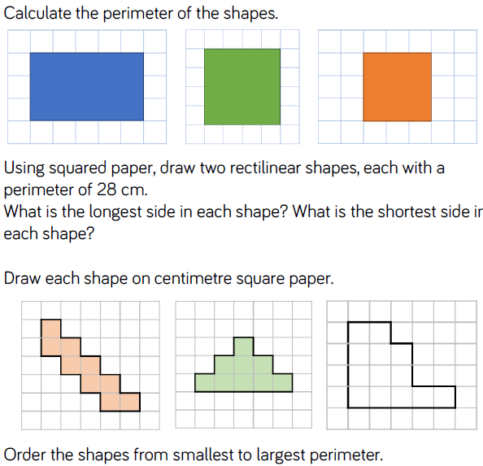
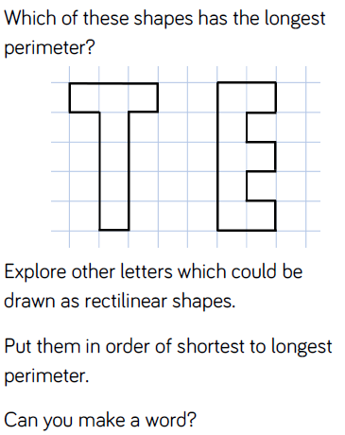
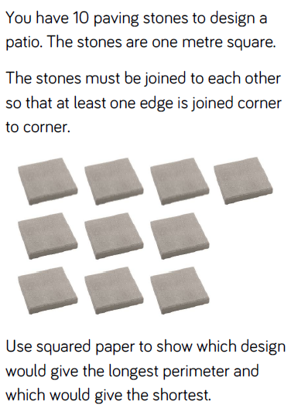

Day | Mental/Oral Starter |  | Main Lesson |  |  |  | Plenary | Assessment
 | Objectives | Activity | Objectives | Teaching | Activities | Key Vocabulary | Activity
Fri | L.O. Recall 12x table  L.O. fluency  433x12 =  687÷12=  8521+1969=  1000-837= | TMM  L.O. To fill in the missing numbers | L.O. To calculate the perimeter of rectangles including squares.  Must: Calculate perimeter of rectangles.  Should: find missing lengths  Could: Investigate and solve problems  Success Criteria | Teach chn to calculate the perimeter of rectangles and squares not on a grid. Chn explore different ways to calculate perimeter: adding all sides together; adding length and width and multiplying by 2.  Children use their understanding of perimeter to calculate missing lengths and to investigate the possible perimeters of squares and rectangles. | Chn calculate perimeter of rectangles uing different methods  Chn use their understanding of perimeter to find missing lengths.  Investigate and solve problems  SEN – L.O. | Metres  Centimetres  Millimetres  Add  Multiply  Perimeter | If I know the perimeter of a shape and the length of one of the sides, how can I calculate the length of the missing side?  Can a rectangle where the length and width are integers, ever have an odd number? | Exceeding ARE:  At ARE:  Below ARE:  SEND  PPG  EAL

