School name: MATHS PLANNING YEAR A
BRONZE
Teacher: Class: Year: Term: Spring 2 Week Commencing: Week 4

Topic |  |  | NC Links:  Pupils should be taught to:
Day | Mental/Oral Starter |  |  | Main Lesson |  |  |  | Plenary | Assessment
 | Objectives | Activity |  | Objectives | Teaching | Activities | Key Vocabulary | Activity
Mon | L.O. Recall 9x table  612 x 9 =  821 ÷ 9 =  3079 + 951 =  5000 - 3214 =  1.8m = ?cm | TMM  L.O. To fill in the missing gaps |  | L.O. To Subtract Fractions  Must: Subtract fractions using bar models.  Should: Subtract fractions using part/whole models  Could: Explain methods  Success Criteria | Teach children to use practical equipment and pictorial representations to subtract fractions with the same denominator within one whole.  They must understand that we only subtract the numerators and the denominators stay the same. | Chn use bar models and number stories to explain a pictorial representation.  Use part/whole models to subtract fractions  Explain methods  SEN – L.O. | Fraction  Denominator  Numerator  Difference  Take away  Subtract | What fraction is shown first? Then what happens? Now what is  left? Can we represent this in a number story? | Exceeding ARE:  At ARE:  Below ARE:  SEND  PPG  EAL

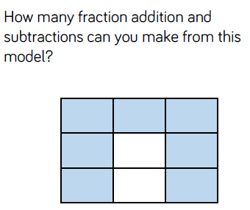
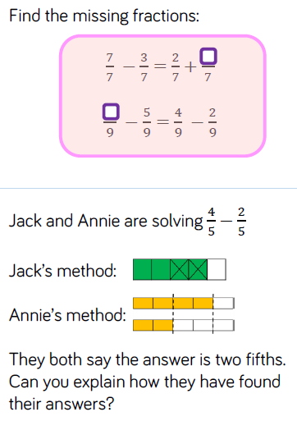
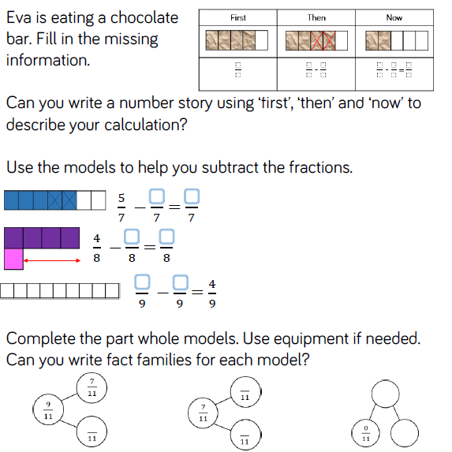

Day | Mental/Oral Starter |  | Main Lesson |  |  |  | Plenary | Assessment
 | Objectives | Activity | Objectives | Teaching | Activities | Key Vocabulary | Activity
Tues | L.O. Recall 9x table  1515 - 795 =  37 + 2578 =  547 x 9 =  575 ÷ 9 =  35cm = ?mm | TMM  L.O. To fill in a Venn Diagram. | L.O. To add 2 or more fractions.  Must: Add 2 or more fractions of the same denominator within a whole.  Should: Add 2 or more fractions of the same denominator beyond a whole.  Could: Explain word problems involving adding 2 or more fractions that end in mixed/improper fraction  Success Criteria | Children use practical equipment and pictorial representations to add two or more fractions with the same denominator which total less than 1. Then record numbers greater than 1 using mixed numbers.  Only add the numerator, the denominator stays the same. | Use strips of folded card to add quarters.  Use bar models and number lines to add fractions  Spot, explain and correct errors.  Explain calculations that add to a mixed number/improper fraction.  SEN – L.O. | Fraction  Add  Subtract  Total  whole  Denominator  Numerator  Improper  Mixed number | How  many equal parts is the whole split into? How many equal  parts am I adding  Which bar model do you prefer when adding fractions? Why?  Can you combine any pairs of fractions to make one whole  when you are adding three fractions? | Exceeding ARE:  At ARE:  Below ARE:  SEND  PPG  EAL

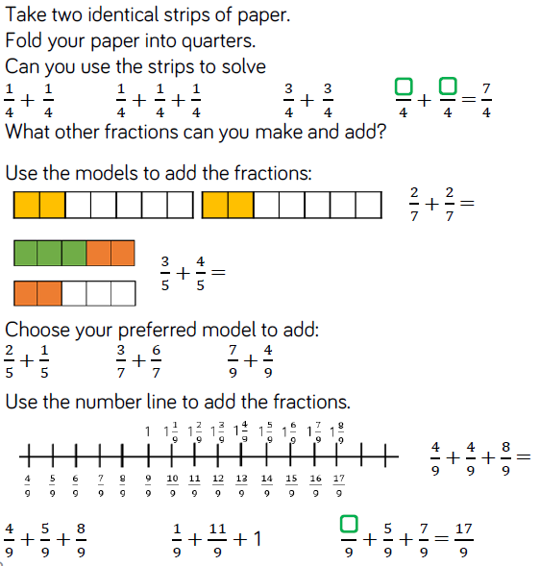
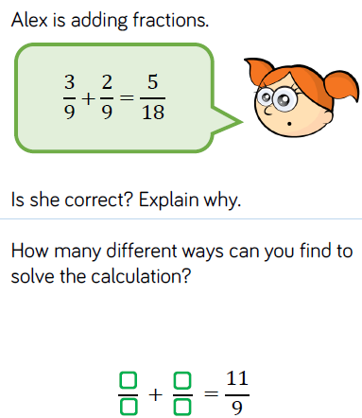
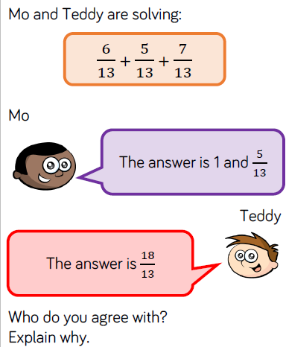

Day | Mental/Oral Starter |  | Main Lesson |  |  |  | Plenary | Assessment
 | Objectives | Activity | Objectives | Teaching | Activities | Key Vocabulary | Activity
Wed | L.O. To recall 9x table  4000 - 745 =  446 x 9 =  771 ÷ 9 =  1009 + 4174 =  15cm = ?mm | TMM  L.O. To fill in a web | L.O. To Subtract fractions  Must: use folded card to calculate fractions  Should: use bar models and number lines to subtract fractions  Could: Spot, explain and correct errors.  Success Criteria | Children use practical equipment and pictorial representations to subtract fractions with the same denominator.  Encourage children to explore subtraction as take away and as difference. Difference can be represented on a bar model by using a comparison model and making both fractions in the subtraction. | Use folded card to solve subtraction of eighths  Use bar models and number lines to subtract fractions  Match number story to correct statement.  Spot, explain and correct errors  SEN – L.O. | Fraction  Denominator  Numerator  Difference  Take away  Subtract | How can I find a missing number in a subtraction? Can you count on to find the difference?  Can I partition my fraction to help me subtract? | Exceeding ARE:  At ARE:  Below ARE:  SEND  PPG  EAL

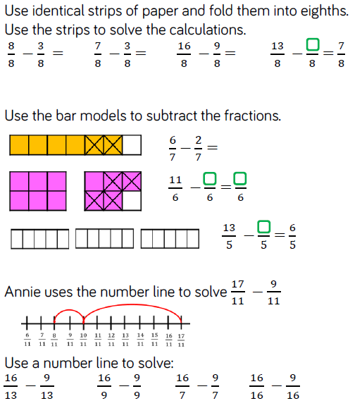
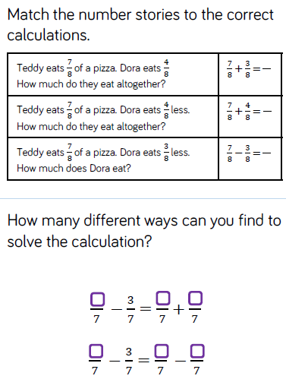
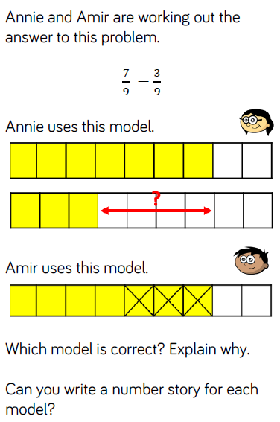

Day | Mental/Oral Starter |  | Main Lesson |  |  |  | Plenary | Assessment
 | Objectives | Activity | Objectives | Teaching | Activities | Key Vocabulary | Activity
Thurs | L.O. To recall 9x table  652 + 6547 =  500 - 332 =  952 x 9 =  654 ÷ 9 =  50cm = ?m | TMM  L.O. To solve a multiplication pyramid | L.O. To subtract fractions from a whole one.  Must: use folded card to calculate fractions  Should: use bar models and number lines to subtract fractions  Could: Solve problems  Success Criteria | Children continue to use practical equipment and pictorial representations to subtract fractions.  Children subtract fractions from a whole amount. Children need to understand how many equal parts are equivalent to a whole e.g. 99= 1, 189= 2 etc. | Use cubes, card, bar models and number lines to solve calculations.  Spot, explain and correct errors.  Solve problems.  SEN – L.O. | Fraction  Denominator  Numerator  Difference  Take away  Subtract | What do you notice about the numerator and denominator when a fraction is equal to one whole? | Exceeding ARE:  At ARE:  Below ARE:  SEND  PPG  EAL

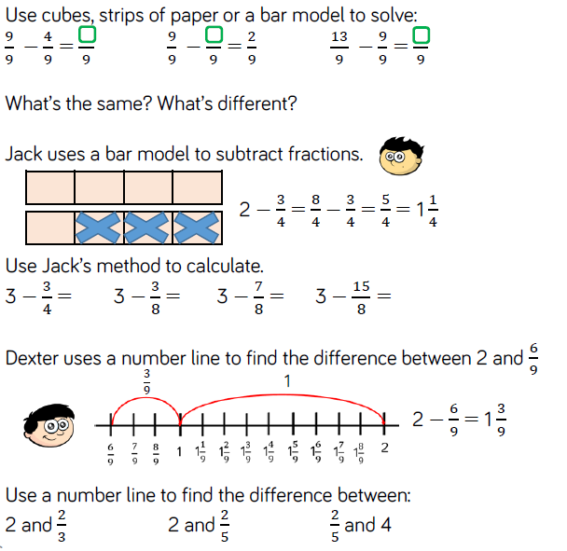
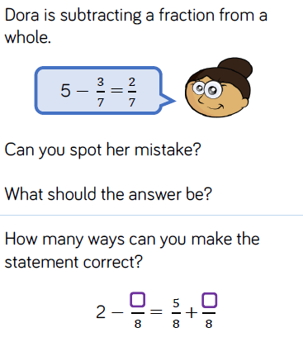
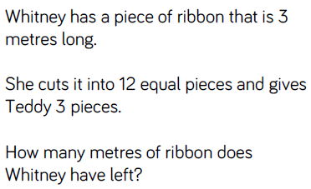

Day | Mental/Oral Starter |  | Main Lesson |  |  |  | Plenary | Assessment
 | Objectives | Activity | Objectives | Teaching | Activities | Key Vocabulary | Activity
Fri |  |  | L.O.  Success Criteria |  | SEN – L.O. |  |  | Exceeding ARE:  At ARE:  Below ARE:  SEND  PPG  EAL

