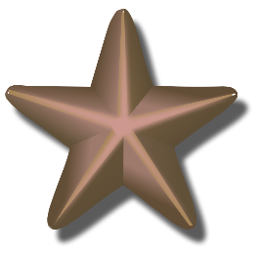
School name: MATHS PLANNING YEAR A
BRONZE
Teacher: Class: Year: Term: Spring 2 Week Commencing: Week 5

Topic |  |  | NC Links:  Pupils should be taught to:
Day | Mental/Oral Starter |  |  | Main Lesson |  |  |  | Plenary | Assessment
 | Objectives | Activity |  | Objectives | Teaching | Activities | Key Vocabulary | Activity
Mon | L.O. Recall 11x table  469 x 11 =  634 ÷ 11 =  65 + 5499 =  1000 - 667 =  3m = ?cm | TMM  L.O. To join the 11x facts |  | L.O. To recognise and write tenths.  Must: Recognise and write tenths to one whole  Should: Recognise and write tenths beyond one whole.  Could: Identify odd one out  L.O. To count in tenths.  Must: count forwards in tenths  Should: count backwards in tenths  Success Criteria | Teach children to explore what a tenth is. They recognise it is one whole divided into ten equal parts. They represent tenths in different ways.  Children move to decimal tenths beyond one and finally relate the decimal to the fraction equivalent.  Children count up and down in tenths using different  representations.  Children also explore what happens when counting past  1010They are not required to write mixed numbers, however  children may see the  1110as 1 1110due to their understanding of 1  whole. | Identify tenths in pictorial representations and write answers in words, fractions and decimals.  Part-whole models to make whole numbers from tenths beyond 1  Odd one out exercise  Count forwards and backwards in tenths beyond 1  SEN – L.O. | Decimal Fraction  whole  Denominator  Numerator  tenths | How many tenths make the whole?  How many more tenths do I need to make a whole?  Let’s count in tenths. What comes next? Explain how you know.  If I start at ___ tenths, what will be next? | Exceeding ARE:  At ARE:  Below ARE:  SEND  PPG  EAL
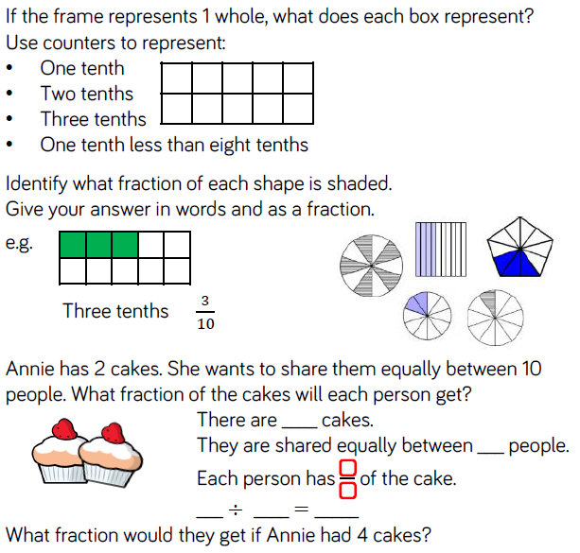
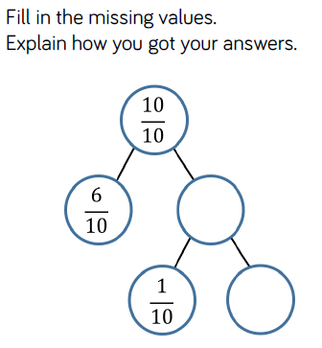
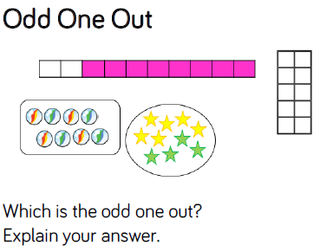

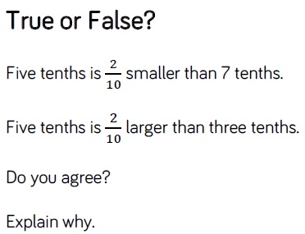

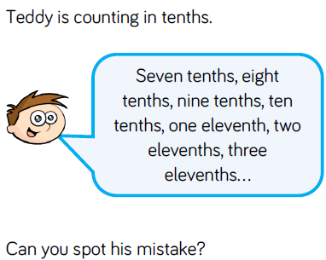

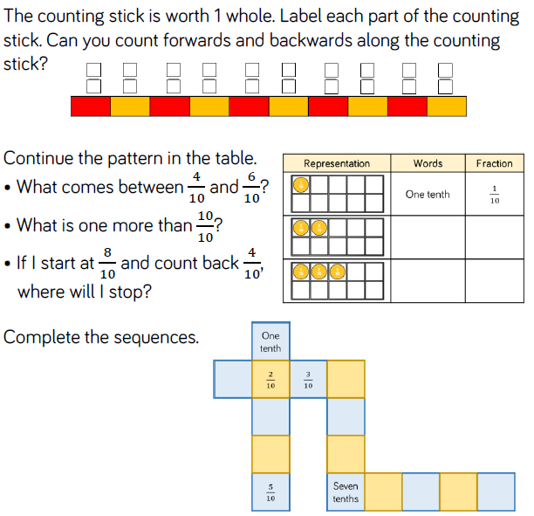

Day | Mental/Oral Starter |  | Main Lesson |  |  |  | Plenary | Assessment
 | Objectives | Activity | Objectives | Teaching | Activities | Key Vocabulary | Activity
Tues | L.O. Recall 11x table  3946 + 1779 =  750 - 289 =  407 x 11 =  398 ÷ 11 =  70cm = ?mm | TMM  L.O. To fill in a web | L.O. To understand tenths as decimals.  Must: write tenths in words, fractions and decimals  Should: Explain true or false statements  Could: Place fractions and decimals on a number line  Success Criteria | Children are introduced to tenths as decimals for the first time. They compare fractions and decimals written as words, in fraction form and as decimals and link them to pictorial representations.  Children learn that the number system extends to the right of the decimal point into the tenths column. | Chn see images and write the tenths in words, fractions and decimals.  True or false statements explained  Place decimals and fractions on a number line  SEN – L.O. | Decimal Fraction  Tenths | What is a tenth?  How many different ways can we write a tenth?  What does equivalent mean?  What is the same and what is different about decimals and  fractions? | Exceeding ARE:  At ARE:  Below ARE:  SEND  PPG  EAL

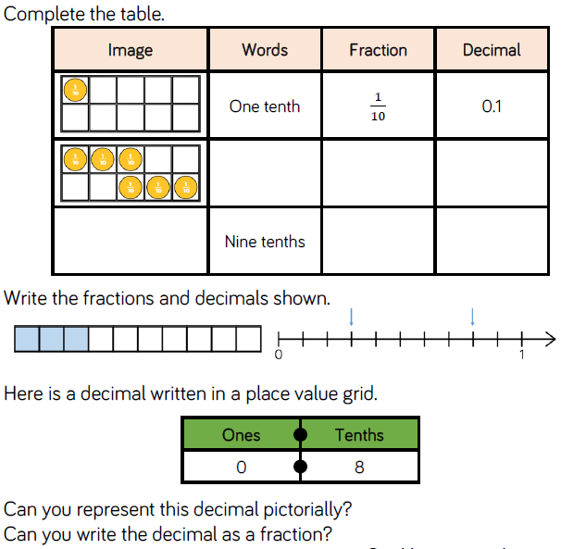
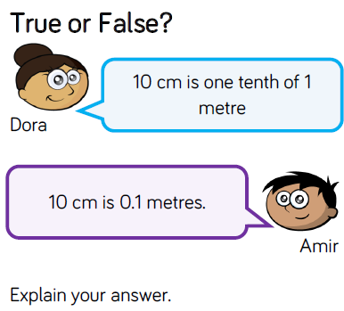
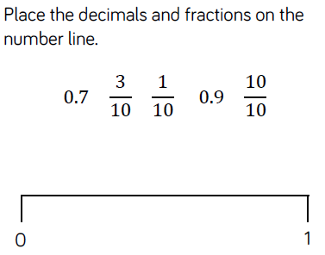
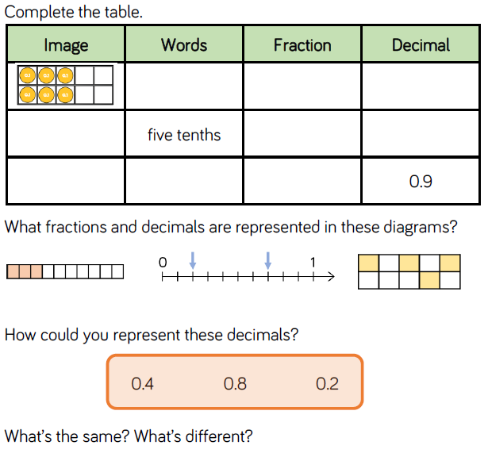
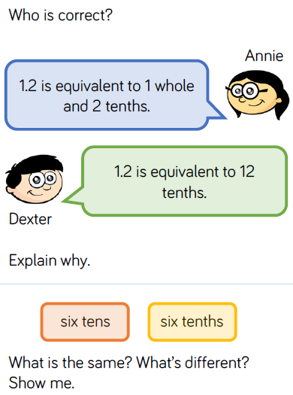
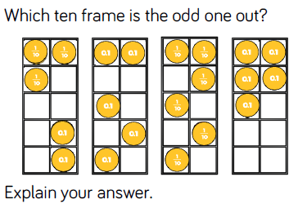

Day | Mental/Oral Starter |  | Main Lesson |  |  |  | Plenary | Assessment
 | Objectives | Activity | Objectives | Teaching | Activities | Key Vocabulary | Activity
Wed | L.O. Recall 11x table  5406 + 1549 =  999 - 257 =  177 x 11 =  888 ÷ 11 =  50cm = ?mm | TMM  L.O. Solve a multiplication pyramid problem | L.O. To write and recognise hundredths.  Must: Recognise and write hundredths to one whole  Should: Explain how tenths relate to hundredths  Could: Partition decimals into tenths and hundredths  Success Criteria | Children recognise hundredths (and tenths) using a hundred square. They see that 10 hundredths equal 1 tenth and can use a part whole model to partition a fraction into tenths and hundredths. | Use a hundred square to relate tenths and hundredths to a whole by recording shaded squares, columns and rows as tenths and hundredths.  Explain how tenths relate to hundredths  Partition decimals into tenths and hundreds.  SEN – L.O. | Decimal Fraction  whole  Denominator  Numerator  Tenths  Hundredths  partition | If each row is one row out of ten equal rows, what fraction does this represent?  If each square is one square out of one hundred equal squares, what fraction does this represent?  How many hundredths are in one tenth? | Exceeding ARE:  At ARE:  Below ARE:  SEND  PPG  EAL

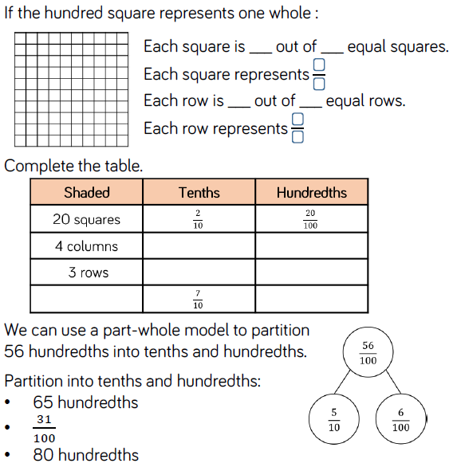
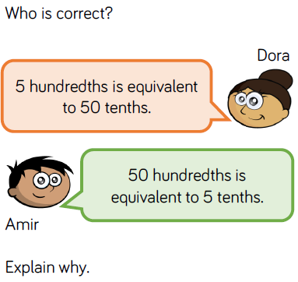
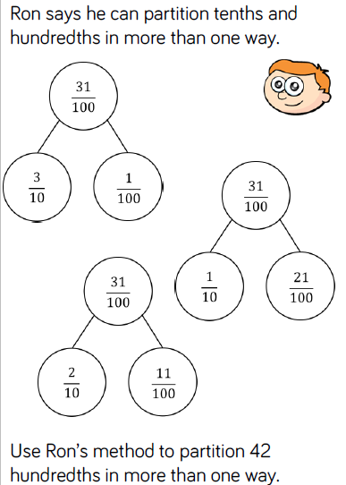

Day | Mental/Oral Starter |  | Main Lesson |  |  |  | Plenary | Assessment
 | Objectives | Activity | Objectives | Teaching | Activities | Key Vocabulary | Activity
Thurs | L.O.To recall 11x table  5886+2154 =  810 -366 =  247 x 11 =  300 ÷ 11 =  90cm = ?mm | TMM  L.O. To join the 11x facts | L.O. To record tenths on a place value grid and number line  Must: Record decimals on a place value chart.  Should: Complete number line.  Could: Complete number lines of different scales.  Success Criteria | Children read and represent tenths on a place value grid. They  see that the tenths column is to the right of the decimal point.  Children use concrete representations to make tenths on a place value grid and write the number they have made as a  decimal.  In this small step children will be introduced to decimals greater than 1  Children read and represent tenths on a number line.  They link the number line to measurement, looking at measuring in centimetres and millimetres.  Children use number lines to explore relative scale. | Chn record tenths greater than 1 on a place value grid noting the partition.  Use 5 place value counters to make as many numbers as possible.  Chn complete number lines of different scale  Place decimals on a number line  SEN – L.O. | Tenths  Place value  Number line  Decimals  Cm  Mm | Why do we need to use the decimal point?  How many equal parts are between 0 and 1?  What are the intervals between each number?  How many tenths are in one whole?  What is 0.1 metres in millimetres? | Exceeding ARE:  At ARE:  Below ARE:  SEND  PPG  EAL

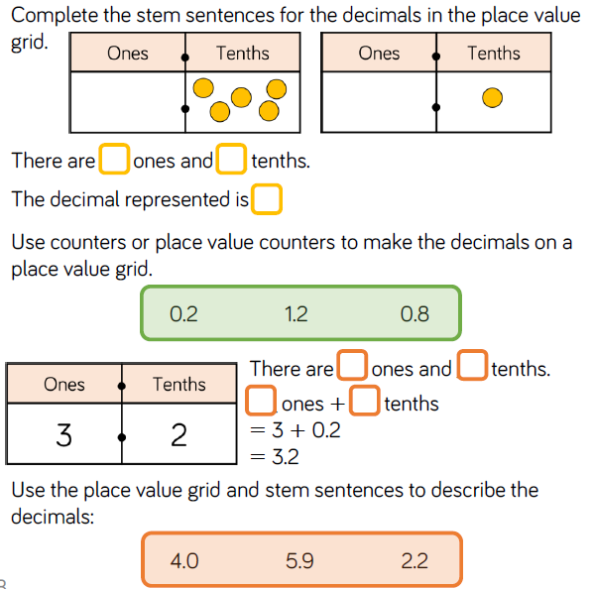
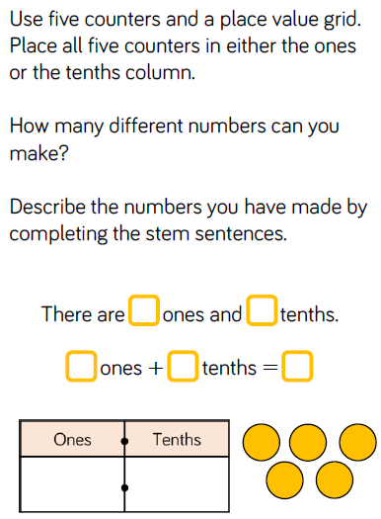
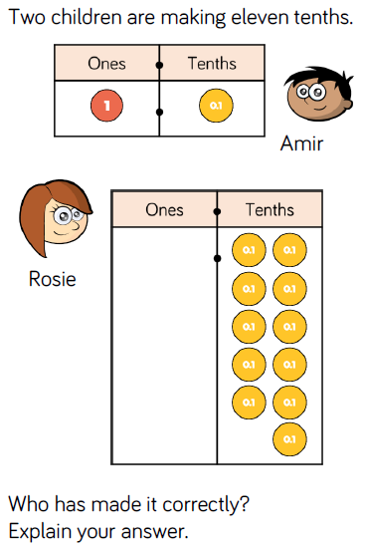
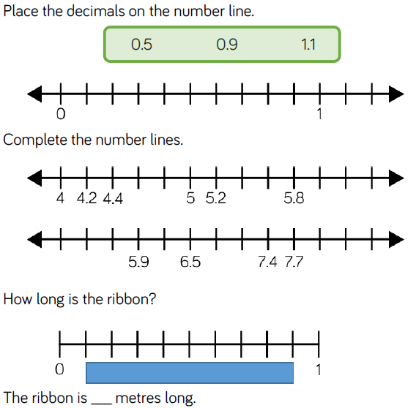
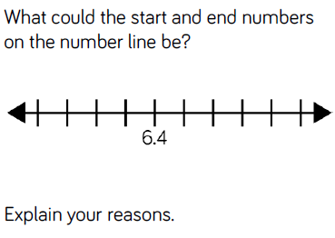
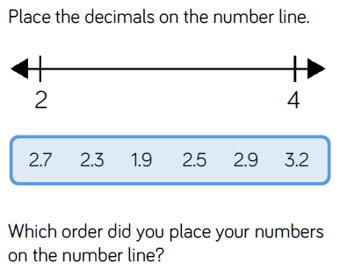

Day | Mental/Oral Starter |  | Main Lesson |  |  |  | Plenary | Assessment
 | Objectives | Activity | Objectives | Teaching | Activities | Key Vocabulary | Activity
Fri | L.O. To recall 12x table  541 x 12 =  631 ÷ 12 =  5014 +3365=  700-319=  75cm = ?mm | TMM  L.O. To solve a multiplication table | L.O. To Understand Hundredths  Must: Record decimals on a number line.  Should: Complete number sequences  Could: Fill a table using words, fractions and decimal.  Success Criteria | Children recognise that hundredths arise from dividing one whole into one hundred equal parts.  Linked to this, they see that one tenth is ten hundredths.  Using the hundred square and Base 10, children can recognise the relationship between 1/100and 0.01  Children write hundredths as decimals and as fractions. They write any number of hundredths as a decimal and represent the decimals using concrete and pictorial representations.  In this small step children stay within one whole. | Chn complete number lines and sequences involving hundredths.  Fill in a table that shows pictorial, words, fractions and decimals.  SEN – L.O. | Tenths  Hundredths  Number line  Sequences  Divide | One hundredth is one whole split into how many equal parts?  How many hundredths can I exchange one tenth for?  How many hundredths are equivalent to 5 tenths? | Exceeding ARE:  At ARE:  Below ARE:  SEND  PPG  EAL

