Catalan
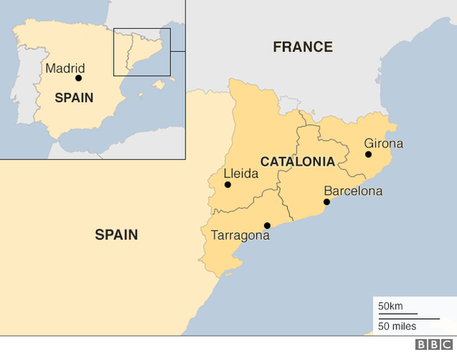
Catalan is a Romance language of the Indo-European family. It is native to Spain, Andorra, France, and Italy. There are about 4,100,000 (4.1 million) native Catalan speakers.
The name Catalan comes from the north-eastern region of Catalonia in Spain. Barcelona is the capital city of the autonomous community of Catalonia in Spain and is also Spain’s 2nd largest city.
Catalan is also spoken in the neighbouring regions of Valencia (known there as Valencian language), the Balearic Islands including Mallorca, and the island of Ibiza.

First words
 | Spanish | Catalan
Welcome | Bienvenidos (m)  Bienvenidas (f) | Bienvingut
Hello | Hola | Hola
Goodbye | Adiós | Adéu
Yes | Sí | Sí
No | No | No
Thank you | Gracias | Gràcies
Please | Por favor | Si us plau
Sorry | perdón | Ho sento
Good Morning | Buenos días | Bon dia
Good afternoon | Buenas tardes | Bona tarda
Come here | Ven aca | Vine aquí
Well done | Muy bien | Ben fet
Try and guess how to pronounce these words.
Numbers 1 to 10

 | Spanish | Catalan
1 - one | uno | un
2 - two | dos | dos
3 - three | tres | tres
4 - four | cuatro | quatre
5 - five | cinco | cinc
6 - six | seis | sis
7 - seven | siete | set
8 - eight | ocho | vuit
9 - nine | nueve | nou
10 - ten | diez | deu

Practice counting to 10.
Can you count backwards from 10 to 1

Questions and answers
What’s your name? my name is …
Spanish | ¿Cómo te llamas? | Mi nombre es....
Catalan | Quin és el teu nom? | El meu nom és ....

How old are you? I am five years old
Spanish | ¿Cuántos años tienes? | Tengo cinco años.
Catalan | Quants anys tens? | Tinc cinc anys

How are you? I am very good
Spanish | ¿Cómo estás? | Muy bien.
Catalan | Com estàs? | Estic molt bé

What is this? That is a pencil
Spanish | ¿Qué es esto? | Esto es un lápiz.
Catalan | Què és això? | Això és un llapis

Do you understand? I don’t understand
Spanish | ¿Entiendes? | No entiendo.
Catalan | Entens? | No ho entenc

Can you try to find how you might reply to these questions with different answers?
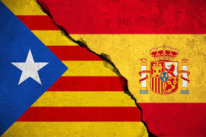
Catalan vs Spanish
Catalan is the second most spoken in Spain after Spanish.
Although both official languages in Spain, Catalan and Spanish are distinct languages. Catalan is not a dialect of Spanish.
Both Spanish and Catalan date back to the Romans. Although Spanish culture and literature is well known, Catalan also has a fine cultural and literary tradition dating back to the early middle ages.
Both are Western Romance languages based on Latin. Spanish and Portuguese belong to the Iberio-Romance family. Meanwhile Catalan is an Occitano-Romance language with Occitan, a language of Southern France.
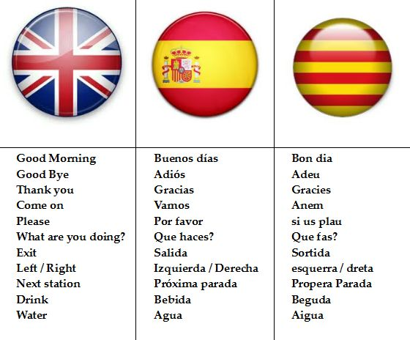
Although distinct languages, in some ways, the difference between Catalan and Spanish is not so huge. They share words and grammar in common. Observers may also hear Catalan’s similarities to French and Italian languages.
There are pronunciation differences between Catalan and Spanish. In Spanish, there are five vowels and five pronunciations for those vowels. They do not change. In Catalan, the “a”, “o” and “e” change their pronunciation whether they are stressed or unstressed. Also, there are more vowels in Catalan (8) that do not exist in Spanish, like é (closed e), è (opened e), ó (closed o), ò (opened o), and ú (always closed).
The difference between Catalan and Spanish also involves important cultural and political knowledge about Spain. The Catalan language is a source of pride for those regions that speak it. Under the Franco dictatorship from 1936 to 1975, Catalan was banned. Spain transitioned to democracy after 1975 and Catalan became an official language for media, education, and public life.
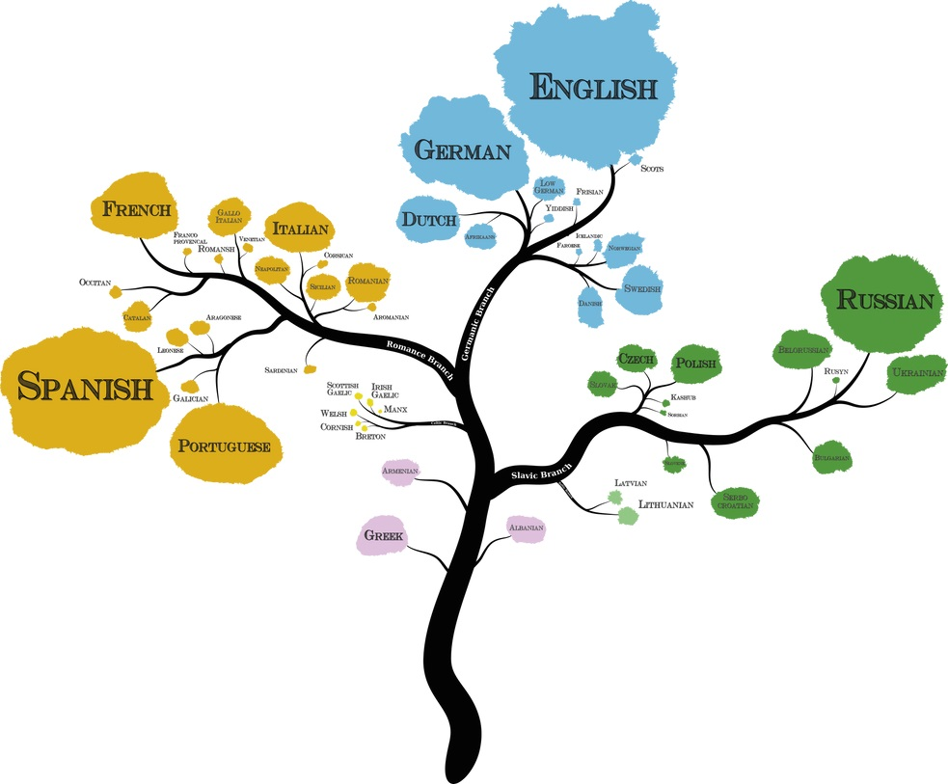
The historic debate of Spanish vs Catalan dates back to the roots of romance languages in Europe. They are both Western Romance Languages but come from different branches. Spanish is from Iberian-Romance (which includes Portuguese) and Catalan is from Gallo-Romance (which includes French).
Catalonia is an autonomous region and perhaps the richest part of Spain. There is a strong movement to obtain total independence from Spain, so far rejected. Regardless of whether Catalonia becomes independent or continues to be part of Spain, its strong regional character is certain to stay.
Catalan has been banned and repressed several times during its history. It was banned for the first time in 1714 after the Catalans’ defeat in the War of Spanish Succession. The Spanish language was used to unify Spain and the use of Catalan declined as a result. Catalan was banned once again in the 20th century. From 1940 to 1978, Catalan was strictly banned by Franco. Despite this, Catalan managed to survive and is today spoken by over 9 million people.
Catalan has six dialects, from East to West. They are:
- Alguerese, spoken in Alghero;
- Balearic, spoken in the Balearic Islands;
- Rousellonese, spoken in Roussillon, a region in southern France;
- Central Catalan, spoken mainly in Barcelona, Tarragona and Girona;
- Northwestern Catalan, spoken in Lleida, in parts of Tarragona and La Franja;
- Valencian, spoken in Valencia.

